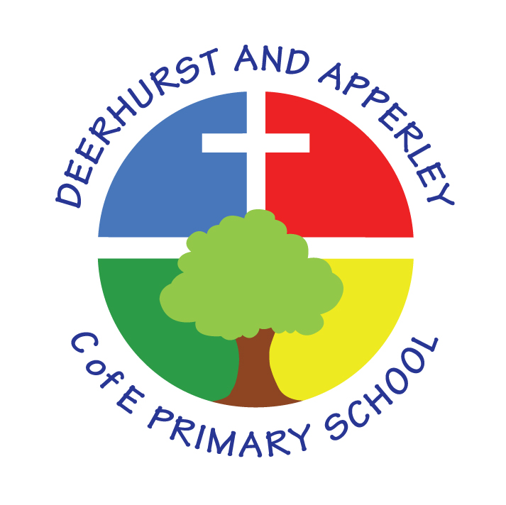

PSHCE and Well Being Policy

Reviewed June 2025
This policy needs to be read along with:
RSE Policy
Safeguarding and Child Protection
Anti- Bullying Policy
Behaviour Policy

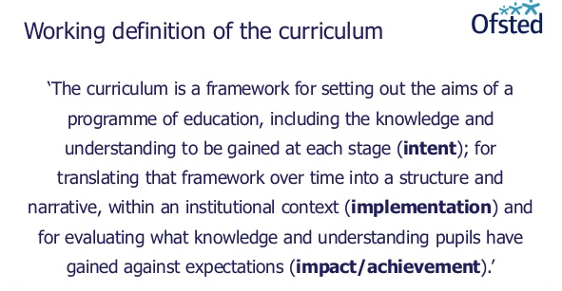

The Curriculum at Deerhurst and Apperley is:
BALANCED: by promoting the intellectual, moral, spiritual aesthetic, creative emotional and physical development of each child. This intent is aligned to objectives in school and national policy objectives. Staff have a shared understanding of intent, implementation and impact and consistent teaching and marking methods are used (Implementation) to ensure impact on pupils.
RIGOROUS: the curriculum takes into account disciplinary habits of mind – disciplinary specific, powerful ways of thinking that are developed through sustained engagement with the discipline. For example, inverse operations in maths, cause and effect in science and provenance and context in history. This is all part of the implementation of the framework itself.
COHERENT: the curriculum is designed to promote the development of capabilities across subjects – for example, children learn about graphs in maths before it is needed in science. The design of our curriculum implementation will lead to impact through this coherence.
VERTICALLY INTEGRATED: it is clear how material taught in one year builds on what was learned in previous years, and how it leads on to subsequent learning. School clearly sets out the objectives each year and they are made clear at the implementation of the curriculum and the intent of how objectives will be transferred into processes, such as subject coverage, medium term plans and termly plans. The methods then developed in the classroom with objectives and marking will then reinforce implementation.
APPROPRIATE: the curriculum provides challenge for students when it is implemented and is planned for impact when study is ongoing or complete. That it meets the needs of all learners.
RELEVANT: the curriculum will be relevant and take into account the interest, needs and wishes of children, but within a framework of informed choice in respect of pedagogy and curriculum. School make clear objectives from national intent of the curriculum which are transferred clearly into implementation within school processes which lead to outcomes (Impact) of the school objectives and those of the children.

Subject Intent

PHSCE is an embedded part of our broad and balanced curriculum. Pupils’ spiritual, moral, social and cultural (SMSC) development is at the heart of our school ethos. This policy reflects our overarching aims and objectives in supporting our children to become healthy and responsible members of society, as well as preparing them for life and work in modern Britain.

Our PSHCE curriculum and wider opportunities allow our children to share their views, thoughts and feelings, as well as Christian faith and witness, with the wider community.

- Aims and Objectives

Personal, social, health education and citizenship enables children to become healthy, independent and responsible members of society. We encourage our pupils to play a positive role in contributing to the life of the school and the wider community. In so doing we help develop their sense of self-worth. We teach them how society is organised and governed. We ensure that they experience the process of democracy in school through the school council. We teach them about rights and responsibilities. They learn to appreciate what it means to be a positive member of a diverse multicultural society. We teach them that bullying is not an accepted behaviour (refer to behaviour policy) and that our school has a zero tolerance with regards bullying. We are a healthy school and promote healthy life styles for future well-being by leading by example and through education and focus weeks.

The aims of personal, social, health education and citizenship are to enable the children to:
- Know and understand what constitutes a healthy lifestyle;
- Be aware of safety issues;
- Understand what makes for good relationships with others;
- Accept that not everyone thinks the same and accept others’ point of view;
- Have respect of others;
- Be independent and responsible members of the school community;
- Be positive and active members of the school community;
- Develop self-confidence and self-esteem, and make informed choices regarding personal and social issues;
- Develop good relationships with other members of the school and the wider community.

- How is PHSCE taught?

Teaching and learning style

We use a range of teaching and learning styles. We place an emphasis on active learning by encouraging the children in discussion, investigations and problem-solving activities. We encourage the children to take part in a range of practical activities that promote active citizenship e.g. charity fundraising; Rags to Riches, Operation Christmas Child, Teams 4 U (Shoe boxes to school) as well as taking part in whole school or class worship. Children are also encouraged to take part in activities to help other individuals or groups less fortunate than themselves, We organise classes in such a way that pupils are able to participate in discussion to resolve conflicts or set agreed classroom rules of behaviour. We offer children the opportunity to hear visiting speakers, Cyber Safety Talks, Police, Pets as Therapy and representatives from the local church, whom we invite into the school to take about their role in creating a positive and supportive local community. Throughout school there is a focus on developing pupils’ self-esteem and giving them opportunities to develop leadership and co-operative skills.

How is SMSC developed through PSHCE?

Spiritual | Promotes self-esteem and explore creativity and imagination
Moral | Explore moral issues through discussions about different viewpoints, ideas and opinions
Social | Promote collaborative learning and celebrate children’s achievements through the display of PSHCE work
Cultural | Explore different cultures, including that of Great Britain, to stimulate discussion of different viewpoints and opinions.

Impact

At Deerhurst and Apperley, we believe that quality PHSCE provides and inspires personal expression, cultural understanding, creative and practical responses, promoting imaginative risk taking to provide solutions to our material, emotional, social and virtual worlds. This will enable pupils to contribute as confident citizens and future professionals to the culture, creativity, economic success, leisure, material and emotional wellbeing of our society within both national and global contexts.

As pupils progress, they should be able to think critically and develop a more rigorous understanding of themselves and the world around them. They should be able to make links to other areas of learning and develop their sense of self and well being. PHSCE sessions are great opportunities to provide a cultural rich programme where resources or teacher support our SEN and vulnerable groups to achieve to the best of their ability. Equipment, resources and teacher support is differentiated when appropriate for children.

Children are given opportunities to demonstrate Building Learning Power such as:

Resilience: Children will challenge themselves and when something is difficult they think about what they need to do to overcome the hurdle.
Resourcefulness: All teachers give lots of opportunities for children to ask questions and deepen their understanding. They are able to make links to developing confidence and links to school values (perseverance) and BLP (resilience).
Reflectiveness: Throughout the course of a unit children will think about what they have learnt in a lesson and record it.

- PSHE and Citizenship planning (example 2025-2026)

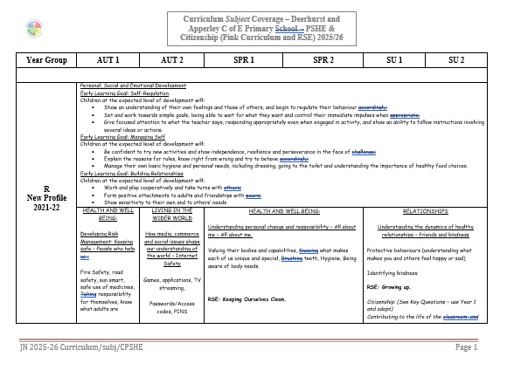

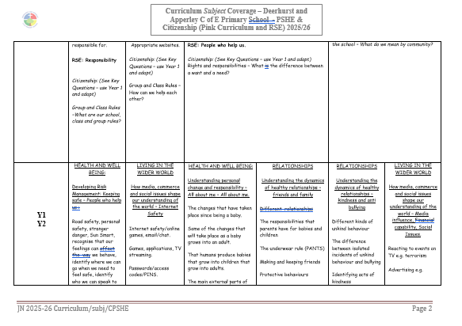

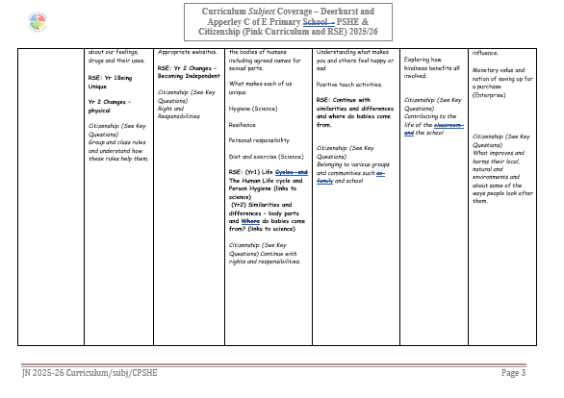
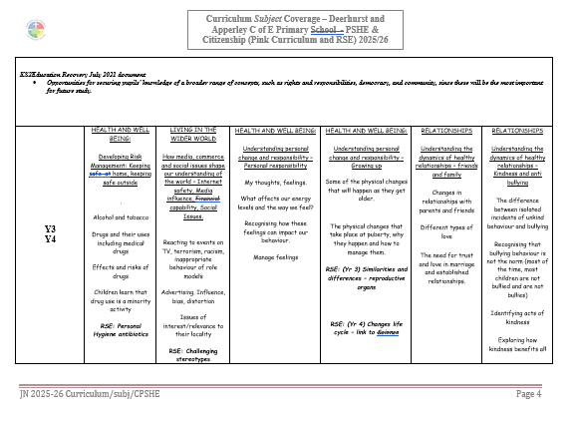

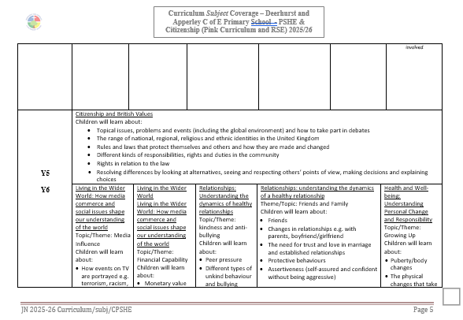

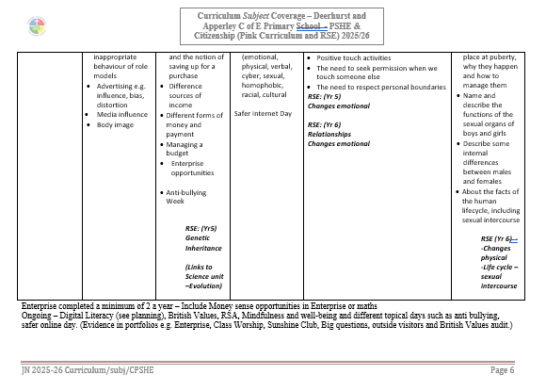

PSHE, is always timetabled and taught throughout our weekly timetable. This will include Mental Health and Wellbeing. Teachers use the Pink Curriculum, SEAL resources, digital literacy resources for keeping safe on line. There are many opportunities in our curriculum to visit British Values and SMSC. All planning highlights those opportunities also. All classes have the opportunity to do an enterprise activity at least twice yearly. This builds on real life skills and supports our rich curriculum.

Mental Health and Well-being
D&A provide a variety of sports clubs, after school and during lunch breaks. We have Playtime Buddies and Talk Partners in school to ensure all children are included in a happy environment on the playground. We also have a well being lunchtime club (Sunshine Club) available twice weekly for children who need a little friendship support or want to share any worries; this is a drop in club but children may also be invited if staff or parents feel there is a need.

Children in school currently have access to Forest School, which involves outdoor learning and creative freedom. All classes have opportunities for Wise Ways of Wellbeing, and wellbeing resources including worry monsters are available in all classrooms. These are used at any relevant opportunities throughout the day.

Children’s views are regularly sought and each year children take part in a child questionnaire.

Implementation, Teaching and Learning Strategies

All teachers provide a safe learning environment through the establishment of clear ground rules, which are made explicit to the children and reinforced consistently.

Non Negotiables
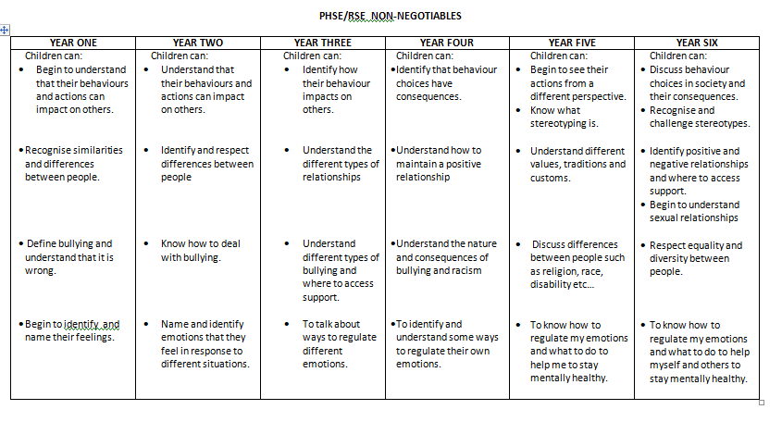
- Early Years Foundation Stage

We teach PSHE in reception classes as an integral part of the topic work covered during the year. As the reception class is part of the Early Years Foundation Stage, we relate the PSHE aspects of the children’s work to the objectives set out in the Early Learning Goals (ELGs). Our teaching in PSHE and Citizenship matches the aims of developing a child’s personal, emotional and social development as set out in the ELGs. We also support citizenship education in infant classes when we teach ‘how to develop a child’s knowledge and understanding of the world’.

Teaching PSHE to children with special needs

We teach PSHE to all children, regardless of their ability. Our teachers provide learning opportunities matched to the individual needs of children with learning difficulties. When teaching PSHE we take into account the targets set for the children on their My Plans etc.

Assessment and Recording

Teachers continually assess the children’s participation in PSHE through AFL and an end of year assessment is recorded on a foundation subject sheet assessment sheet record. During the year children use constructive critique for improvement of each others work. Teachers report to parents about their child’s ability to communicate and make friends and their behaviour.

- Resources

All staff have access to the Pink Curriculum, SEAL, Digital literacy, Anti-bullying resources on the shared teacher drive.

- Monitoring and review

The PSHE subject leader is responsible for monitoring the standards of children’s work and the quality of teaching. The subject leader supports colleagues in the teaching of PSHE, by giving them information about current developments in the subject and by providing a strategic lead and direction for the subject in the school. The subject leader is also responsible for developing an action plan and sharing this with the head teacher.

This policy will be reviewed by staff and presented to the Full Governing Body for approval at the meeting in June 2025

Head teacher: Jayne Neveu Signed: Date:

Chair of Governors: Andy Mathews Signed: Date:

