Class 1  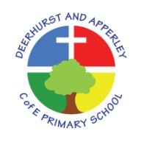 Curriculum Overview 2025-2026  Year group Year 1 & 2 | Term 1 | Term2 | Term3 | Term 4 | Term 5 | Term 6
 | Tiny Time Travellers |  | All Creatures Great and Small |  | Turrets and Tiaras
Geography | WEATHER AND SEASONS  Human and Physical Geography  - Identify seasonal and daily weather patterns in the United Kingdom. |  | HOT AND COLD PLACES  Human and Physical Geography  - identify the location of hot and cold areas of the world in relation to the Equator and the North and South Poles  Geographical Skills and Fieldwork  - use world maps, atlases and globes to identify countries, continents and oceans studied at this key stage |  | MUGURAMENO VILLAGE, ZAMBIA  Place Knowledge  - Understand geographical similarities and differences through studying the human and physical geography of a contrasting non-European country  Human and Physical Geography  - use basic geographical vocabulary to refer to:  - key physical features, including: beach, cliff, coast, forest, hill, mountain, sea, ocean, river, soil, valley, vegetation, season and weather  - key human features, including: city, town, village, factory, farm, house, office, port, harbour and shop  Geographical Skills and Fieldwork  - use world maps, atlases and globes to identify countries, continents and oceans studied at this key stage  You do not have to do this particular area as long as you chose another which is non-European
History | How was school different in the past?  Understanding that although schools have been in the local area for a long time, they have not always been the same; identifying historical similarities and differences; using a range of sources to recognise continuity between children’s lives past and present. |  | How did we learn to fly?  Developing their knowledge of events beyond living memory and reinforcing their chronological understanding by looking at significant events in the history of flight on a timeline. Learning about the individuals who contributed to the history of flight. |  | What is a monarch?  Finding out the role of a monarch, children compare the monarchy today with the monarchy in the past. Pupils investigate how William the Conqueror became King and learn how he used castles to rule. They study different types of castles and consider how these evolved over time.
Art & Design  To produce creative work, exploring their ideas and recording experiences. | Painting  Children can explore using a variety of different brushes to see what happens. Children begin to learn the primary colours and experiment with mixing paints to understand tone and secondary colours.  Artists to choose from:  - Andre Derain  - Gillian Ayres  - Hilma af Klint  - Willem de Kooning  - Joan Mitchell |  | Textile  Children have the opportunity to look at and practise a variety of techniques, e.g. weaving, dyeing and plaiting. They explore which textiles are best to use and produce the best result.  Children will also explore decorating and embellishing their textiles to add detail, colour and effect.  Artists to choose from:  - Cecilia Vicuña  - Marjolein Dallinga  - Elizabeth Armstrong  - Sarkasi Said |  | Printing  Children experiment with shape and pattern, looking at repeated patterns and different materials to make texture.  Artists to choose from:  - Jasper Johns  - Robi Smith  - Arlene Bandes  - Ruth Osborne
Design Technology | Structures – Free Standing  Apply their understanding of building structures and explore how they can be made stronger, stiffer and more stable. Explore, evaluate and design products. |  | Textiles – Templates and Joining  Apply their knowledge to use a range of joining and other practical skills. Use a range of equipment. |  | Dips and Dippers  Understand the basic principles of healthy and varied diets. Use a range of tools to perform practical tasks.
Music | Singing and Performing– Friendship Song  Use their voices expressively and creatively by singing songs and speaking chants and rhymes.  Listen with concentration and understanding to a range of high-quality live and recorded music.  Songs:  - Friendship Song by Joanna Mangona and Pete Readman  - Count On Me by Bruno Mars  - We Go Together (from Grease soundtrack)  - You Give A Little Love from Bugsy Malone  - That's What Friends Are For by Gladys Knight, Stevie Wonder, Dionne Warwick with Elton John  - You've Got A Friend In Me by Randy Newman  VOCAB:  pitch, duration, tempo, beat |  | Playing Instruments  Play tuned and untuned instruments musically.  Experiment with, create, select and combine sounds using the inter-related dimensions of music.  Instrumental progression:  G,A,B |  | Improvisation and Composing  Play tuned and untuned instruments musically.  Experiment with, create, select and combine sounds using the inter-related dimensions of music.  Use their voices expressively and creatively by singing songs and speaking chants and rhymes.  Listen with concentration and understanding to a range of high-quality live and recorded music
Science | All living things and their habitats (Yr 2)  (Do Year 1 pets focus under this section from animals including humans)  Living things and their habitats (yr2)  -Identify that most living things live in habitats to which they are suited and describe how different habitats provide for the basic needs of different kinds of animals and plants, and how they depend on each other  -Identify and name a variety of plants and animals in their habitats, including micro-habitats | Seasonal change and weather (yr1)  All living things and their habitats (yr 2)  Seasonal changes (yr1)  -Observe changes across the four seasons  -Observe and describe weather associated with the seasons and how day length varies.  Living things and their habitats (yr2)  -Explore and compare the differences between things that are living, dead, and things that have never been alive  -Describe how animals obtain their food from plants and other animals, using the idea of a simple food chain, and identify and name different sources of food | Animals including humans.  Animals, including humans (yr1)  -Identify and name a variety of common animals that are birds, fish, amphibians, reptiles, mammals and invertebrates  -Identify and name a variety of common animals that are carnivores, herbivores and omnivores  Animals, including humans (yr2)  -Notice that animals, including humans, have offspring which grow into adults  - Find out about and describe the basic needs of animals, including humans, for survival (water, food and air)  RSE link Life cycles and where do babies come from? | Animals including humans.  Animals, including humans (yr1)  -Describe and compare the structure of a variety of common animals (birds, fish, amphibians, reptiles, mammals and invertebrates, and including pets (pets part completed autumn term))  -Identify, name, draw and label the basic parts of the human body and say which part of the body is associated with each sense.  Animals, including humans (yr2)  -Describe the importance for humans of exercise, eating the right amounts of different types of food, and hygiene.  RSE link Personal hygiene and body parts | Plants (yr1 and yr 2)  Plants (yr1)  -Identify and name a variety of common plants, including garden plants, wild plants and trees, and those classified as deciduous and evergreen  -Identify and describe the basic structure of a variety of common flowering plants, including trees.  Plants (yr2)  -Observe and describe how seeds and bulbs grow into mature plants  -Find out and describe how plants need water, light and a suitable temperature to grow and stay healthy. | Everyday materials  (Yr 1)  Use of everyday materials (Yr2)  Everyday materials (yr1)  -Distinguish between an object and the material from which it is made  -Identify and name a variety of everyday materials, including wood, plastic, glass, metal, water, and rock  -Describe the simple physical properties of a variety of everyday materials  -Compare and group together a variety of everyday materials on the basis of their simple physical properties  Uses of everyday materials (yr2)  -Identify and compare the suitability of a variety of everyday materials, including wood, metal, plastic, glass, brick, rock, paper and cardboard for particular uses.  -Find out how the shapes of solid objects made from some materials can be changed by squashing, bending, twisting and stretching.
Computing  and Digital Literacy  Cycle A  Careers and notable people | Project Evolve  Self-Image and Identity  and  Self-Image and Identity | Project Evolve  Online Relationships  and  Online Relationships | Safer Internet Day 2026  February | Project Evolve  Online Reputation  and  Online Reputation | Project Evolve  Online Bullying  and  Online Bullying
 | COMPUTING SYSTEMS AND NETWORKS |  | PROGRAMMING |  | CREATING MEDIA
 | Technology around us (1.1)  Recognising technology in school and using it responsibly | Information technology around us (2.1)  Identifying IT and how its responsible use improves our world in school and beyond. | Moving a robot (1.3)  Writing short algorithms and programs for floor robots, and predicting program outcomes | Robot algorithms (2.3)  Creating and debugging programs, and using logical reasoning to make predictions. | Digital writing (1.5)  Using a computer to create and format text, before comparing to writing non-digitally. | Digital music (2.5)  Using a computer as a tool to explore rhythms and melodies, before creating a musical composition.
 | Hedy Lamarr  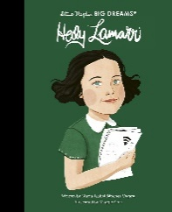 | Barefoot Computing Technology Match | Charles Babbage  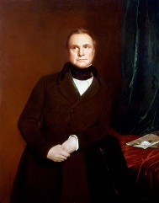 | Ada Lovelace  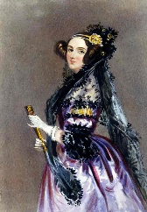 | Digital Copyrighter | 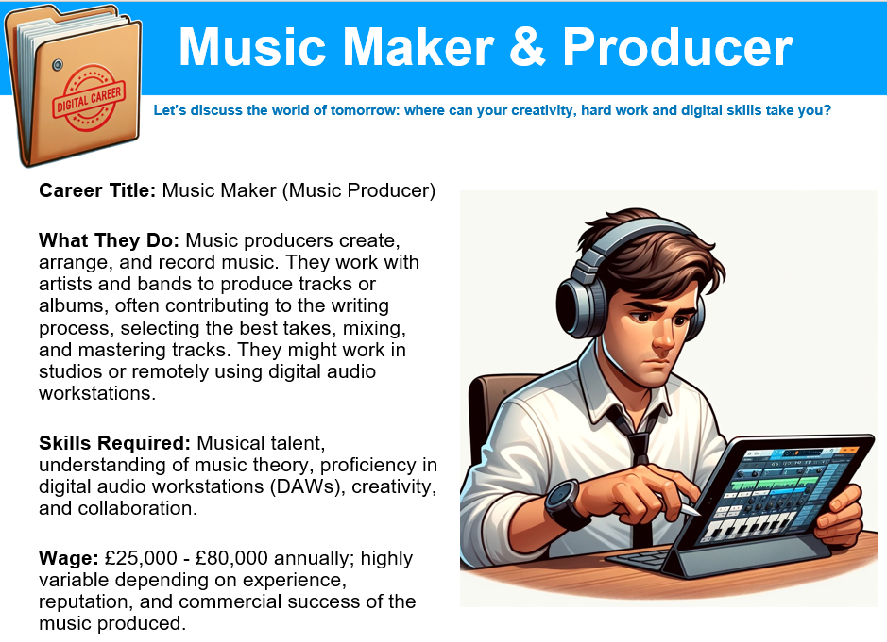
 | Ongoing:  - use technology safely and respectfully, keeping personal information private. (Link to PHSE)  identify where to go for help and support when they have concerns about content or contact on the internet or other online technologies (Link to PHSE) |  | Ongoing:  - use technology safely and respectfully, keeping personal information private. (Link to PHSE)  identify where to go for help and support when they have concerns about content or contact on the internet or other online technologies (Link to PHSE) |  | Ongoing:  - use technology safely and respectfully, keeping personal information private. (Link to PHSE)  identify where to go for help and support when they have concerns about content or contact on the internet or other online technologies (Link to PHSE)
PE | Games (Invasion) and Fitness  Master basic movements including, running, jumping, throwing and catching, as well as developing balance, agility, and cooperation, and begin to apply these in a range of situations  Participate in team games, developing simple tactics for attacking and defending  Perform dances using simple movements. |  | Gymnastics and Dance  Master basic movements including running and jumping, as well as developing balance and agility. |  | Athletics and Games (S&F)  Master basic movements including, running, jumping, throwing and catching, as well as developing balance, agility, and cooperation, and begin to apply these in a range of situations  Participate in team games, developing simple tactics for attacking and defending.
PE | Ongoing:  Develop fundamental movement skills, become increasingly competent and confident and access a broad range of opportunities to extend their agility, balance and coordination, individually and with others. They should be able to engage in competitive (both against self and against others) and co-operative physical activities, in a range of increasingly challenging situations.
RE | 1.1 What do Christians believe God is like?  UC b d f g i | 1.2 Why does Christmas matter to Christians and how do people celebrate it? UC a b h i | 1.7 What is it like to be brought up in a Muslim home in the UK today?  a c e g h | 1.5 What is it like to be brought up in a Hindu home in the UK today? a c e | 1.9 How do stories and art express worldviews?  d e a Christian, Muslim, Hindu, Non -Religious/Humanist
PSHE & Citizenship | HEALTH AND WELL BEING:  Developing Risk Management: Keeping safe – People who help us :  Road safety, personal safety, stranger danger, Sun Smart, recognise that our feelings can effect the way we behave, identify where we can go when we need to feel safe, identify who we can speak to about our feelings, drugs and their uses.  RSE: Yr 1Being Unique  Yr 2 Changes – physical  Citizenship: (See Key Questions)  Group and class rules and understand how these rules help them. | LIVING IN THE WIDER WORLD  How media, commerce and social issues shape our understanding of the world – Internet Safety  Internet safety/online games, email/chat.  Games, applications, TV streaming.  Passwords/access codes/PINS.  Appropriate websites.  RSE: Yr 2 Changes – Becoming Independent  Citizenship: (See Key Questions)  Right and Responsibilities | HEALTH AND WELL BEING:  Understanding personal change and responsibility – All about me – All about me.  The changes that have taken place since being a baby.  Some of the changes that will take place as a baby grows into an adult.  That humans produce babies that grow into children that grow into adults.  The main external parts of the bodies of humans including agreed names for sexual parts.  What makes each of us unique  Hygiene (Science)  Resilience  Personal responsibility  Diet and exercise (Science)  RSE: (Yr1) Life Cycles and The Human Life cycle and Person Hygiene (links to science)  (Yr2) Similarities and differences – body parts and Where do babies come from? (links to science)  Citizenship: (See Key Questions) Continue with rights and responsibilities. | RELATIONSHIPS  Understanding the dynamics of healthy relationships – friends and family  Different relationships  The responsibilities that parents have for babies and children  The underwear rule (PANTS)  Making and keeping friends  Protective behaviours  Understanding what makes you and others feel happy or sad  Positive touch activities.  RSE: Continue with similarities and differences and where do babies come from.  Citizenship: (See Key Questions)  Belonging to various groups and communities such as family and school | RELATIONSHIPS  Understanding the dynamics of healthy relationships – kindness and anti bullying  Different kinds of unkind behaviour  The difference between isolated incidents of unkind behaviour and bullying  Identifying acts of kindness  Exploring how kindness benefits all involved.  Citizenship: (See Key Questions)  Contributing to the life of the classroom and the school | LIVING IN THE WIDER WORLD  How media, commerce and social issues shape our understanding of the world – Media influence, Financial capability, Social Issues.  Reacting to events on TV e.g. terrorism  Advertising e.g. influence.  Monetary value and notion of saving up for a purchase (Enterprise)  Citizenship: (See Key Questions)  What improves and harms their local, natural and environments and about some of the ways people look after them.
MFL | We aim to expose children to MfL vocabulary, such as  Numbers: 0 – 15  Greetings: Hello, Goodbye, Hi, Good Night  Colours: Red, White, Blue, Green, Yellow, Pink, Orange  Fruit: Apple, Orange, Banana, Melon, Strawberry , Pear, Grapes  Instructions: Look, listen, silence, stand up, sit down  Pets: Dog, Cat, Rabbit, Fish | We aim to expose children to MfL vocabulary, such as  Numbers: 0 – 15  Greetings: Hello, Goodbye, Hi, Good Night  Colours: Red, White, Blue, Green, Yellow, Pink, Orange  Fruit: Apple, Orange, Banana, Melon, Strawberry , Pear, Grapes  Instructions: Look, listen, silence, stand up, sit down  Pets: Dog, Cat, Rabbit, Fish | We aim to expose children to MfL vocabulary, such as  Numbers: 0 – 15  Greetings: Hello, Goodbye, Hi, Good Night  Colours: Red, White, Blue, Green, Yellow, Pink, Orange  Fruit: Apple, Orange, Banana, Melon, Strawberry , Pear, Grapes  Instructions: Look, listen, silence, stand up, sit down  Pets: Dog, Cat, Rabbit, Fish | We aim to expose children to MfL vocabulary, such as  Numbers: 0 – 15  Greetings: Hello, Goodbye, Hi, Good Night  Colours: Red, White, Blue, Green, Yellow, Pink, Orange  Fruit: Apple, Orange, Banana, Melon, Strawberry , Pear, Grapes  Instructions: Look, listen, silence, stand up, sit down  Pets: Dog, Cat, Rabbit, Fish | We aim to expose children to MfL vocabulary, such as  Numbers: 0 – 15  Greetings: Hello, Goodbye, Hi, Good Night  Colours: Red, White, Blue, Green, Yellow, Pink, Orange  Fruit: Apple, Orange, Banana, Melon, Strawberry , Pear, Grapes  Instructions: Look, listen, silence, stand up, sit down  Pets: Dog, Cat, Rabbit, Fish | We aim to expose children to MfL vocabulary, such as  Numbers: 0 – 15  Greetings: Hello, Goodbye, Hi, Good Night  Colours: Red, White, Blue, Green, Yellow, Pink, Orange  Fruit: Apple, Orange, Banana, Melon, Strawberry , Pear, Grapes  Instructions: Look, listen, silence, stand up, sit down  Pets: Dog, Cat, Rabbit, Fish

