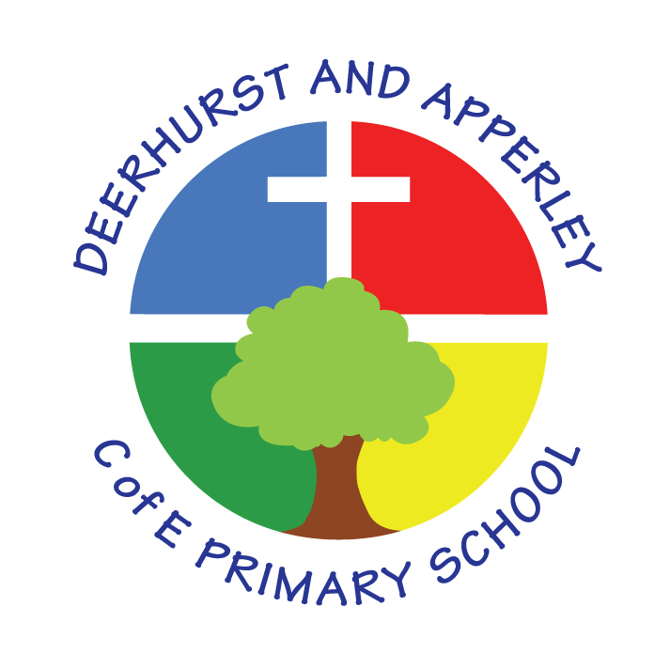**Text Coverage 2025-26**

Please record below the texts you are going to be using with your class this year; this will save any repeats. Please remember to use at least three classics over the year and highlight in yellow (SMSC).

|  |  |  |  |  |
| --- | --- | --- | --- | --- |
| **2024 - 25** | | | | |
| **Term** | **Reception** | **Class 1** | **Class 2** | **Class 3** |
| One | Nursery Rhymes  After the Fall by Dan Santat  Little Red Riding Hood by Miles Kelly  The Last Wolf by Mini Grey  Little Red by Lynn Roberts | Mr Majeika by Humphrey Carpenter (Class Novel)  Julia Donaldson—The singing mermaid Non Fiction: The World’s Most Magnificent Machines by David Long Poetry - The puffin book of fantastic first poems – June Crebbin | Fantastic Beasts and Where To Find Them by J.K. Rowling (Poetry – Just using pictures)  Journey by Aaron Becker  The Book of Stolen Dreams by David Farr (Class Reader)  How to Train a Dragon | The Lost Words by Robert McFarlane and Jackie Morris (poetry)  Tuesday by David Weisner  Wild Boy by Rob Lloyd Jones (Class Novel) |
| Two | The Paper Dolls by Julia Donaldson  Non Fiction – Animals and their habitats  Christmas stories and poetry - various | Theseus and the Minotaur  The Missing Mona Lisa | Cloudbusting by Malorie Blackman  Grimm Tales for Young and Old by Philip Pullman |
| Three | Where the Wild Things Are by Maurice Sendak  How to Catch A Star by Oliver Jeffers  Izzy Gizmo by Pip Jones | The Owl who was afraid of the dark (Class Novel)  Fiction – The Most Important Animal of All  Penny Worms & Hannah Bailey  Non fiction – Pets/animals  Poetry – Apes to Zebras  Roger Stevens | Escape from Pompeii by Caroline Lawrence  Matilda by Roald Dahl (Class Reader)  Poetry Book | Room 13 by Robert Swindells (Class novel) |
| Four | Fiction - Einstein the Penguin by Iona Rangeley & David Tazzyman  Non Fiction - My Body/senses  Poetry – Michael Rosen – I never know how a poem starts | Little Badman and the Invasion of the Killer Aunties by Henry White and Humza Arshad  Dragonology: The Complete Book Of Dragons by Dugald Steer | Letters From the Lighthouse by Emma Carroll |
| Five | Anansi the Spider by Gerald McDermott  Bringing the Rain to Kapiti Plain by Verna Aardema | The boy who grew dragons by Andy Shepherd (Class Novel)  The Dragon Machine by Helen Ward  Non Fiction: Castles | The Tin Forest by Helen Ward  Micheal Rosen  Pages and Co. by Anna James (Class Reader) | Trust Me, Jack’s Beanstalk Stinks by Eric Braun  Holes by Louis Sachar (Class novel) |
| Six | George and the Dragon by  Chris Wormell  Non Fiction Knights  Poetry - Poems Out Loud  Various Poets & Laurie Stansfield | A Planet Full of Plastic  The Valley of Lost Secrets by Lesley Parr (Class Reader) | Wallace and Gromit: The Complete Cracking Contraptions by Nick Park |