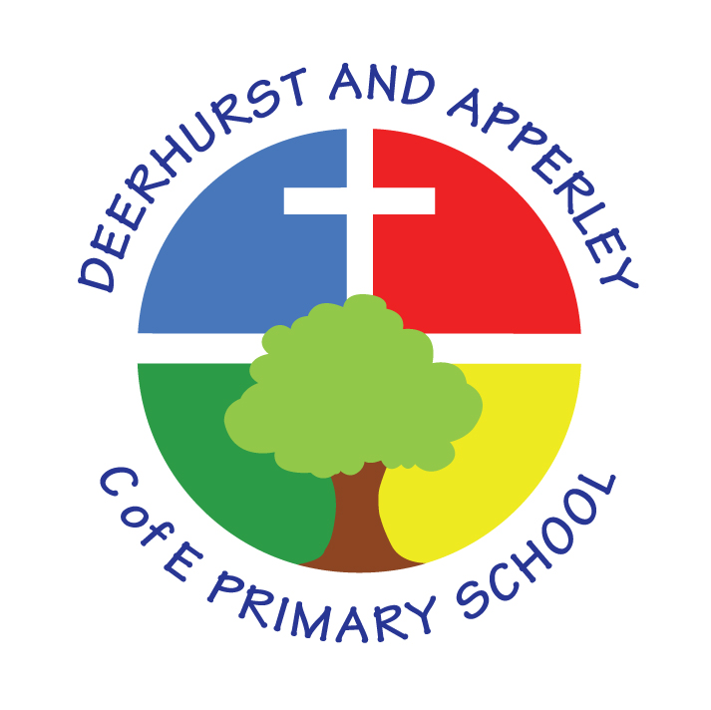

Science Policy

Reviewed July 2022

Science Policy

Our Vision
Through a positive caring environment, we provide the opportunity for every child to reach their full potential. We embrace Christian values and ensure all children are ready for their next steps.

Rationale
Science is a systematic investigation of the physical, chemical and biological aspects of the world which relies on first hand experiences and on other sources of information. The scientific process and pupils’ problem-solving activities will be used to deepen their understanding of the concepts involved. The main aspects of science to be studied will be determined by the programmes of study of the National Curriculum 2014.
Through science pupils at Deerhurst and Apperley will continue to deepen their respect, care and appreciation for the natural world and all its phenomena.

Aims
- to develop pupils’ enjoyment and interest in science and an appreciation of its contribution to all aspects of everyday life
- to build on pupils’ curiosity and sense of awe of the natural world
- to use a planned range of investigations and practical activities to give pupils a greater understanding of the concepts and knowledge of science
- to introduce pupils to the language and vocabulary of science
- to develop pupils’ basic practical skills and their ability to make accurate and appropriate measurements
- to develop pupils’ use of computing in their science studies.
- to extend the learning environment for our pupils via our environmental areas and the locality
- to promote a ‘healthy lifestyle’ in our pupils.

Objectives
The following objectives derived from the above aims will form the basis of our decisions when planning a scheme of work. Assessment will also be related to these objectives:
- to develop pupils’ enjoyment and interest in science and an appreciation of its contribution to all aspects of everyday life.
- to develop a knowledge and appreciation of the contribution made by famous scientists to our knowledge of the world including scientists from different cultures
- to encourage pupils to relate their scientific studies to applications and effects within the real world
- to develop a knowledge of the science contained within the programmes of study of the National Curriculum.
To build on pupils’ curiosity and sense of awe of the natural world
- to develop in pupils a general sense of enquiry which encourages them to question and make suggestions
- to encourage pupils to predict the likely outcome of their investigations and practical activities
To use a planned range of investigations and practical activities to give pupils a greater understanding of the concepts and knowledge of science
- to provide pupils with a range of specific investigations and practical work which gives them a worth-while experience to develop their understanding of science
- to develop progressively pupils’ ability to plan, carry out and evaluate simple scientific investigations and to appreciate the meaning of a ‘fair test’.
To develop the ability to record results in an appropriate manner including the use of
diagrams, graphs, tables and charts
- to introduce pupils to the language and vocabulary of science
- to give pupils regular opportunities to use the scientific terms necessary to communicate ideas about science
- to develop pupils’ basic practical skills and their ability to make accurate and appropriate measurements
- within practical activities give pupils opportunities to use a range of simple scientific measuring instruments such as thermometers and force meters and develop their skill in being able to read them.
To develop pupils’ use of ICT in their science studies
- to give pupils opportunities to use ICT (video, digital camera, data logger) to record their work and to store results for future retrieval throughout their science studies
- to give pupils the chance to obtain information using the internet.
Principles of teaching and learning
Differentiation and Additional Educational Needs
The study of science will be planned to give pupils a suitable range of differentiated activities appropriate to their age and abilities. Tasks will be set which challenge all pupils, including the more able. For pupils with SEN the task will be adjusted or pupils may be given extra support. The grouping of pupils for practical activities will take account of their strengths and weaknesses and ensure that all take an active part in the task and gain in confidence.
Breadth and Balance
Variety.
Pupils will be involved in a variety of structured activities and in more open-ended investigative work:
- activities to develop good observational skills
- practical activities using measuring instruments which develop pupils’ ability to read scales accurately
- structured activities to develop understanding of a scientific concept
- open ended investigations.
On some occasions pupils will carry out the whole investigative process themselves or in small groups.

Non-Negotiables

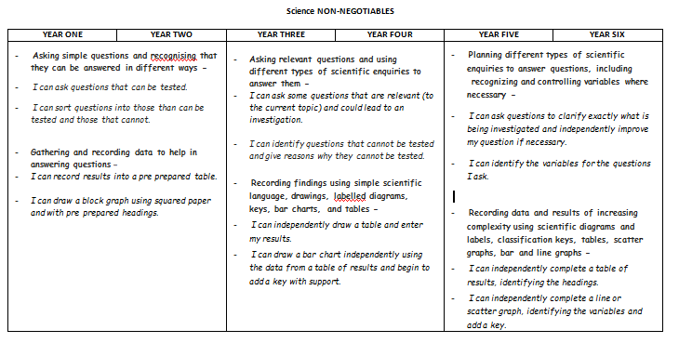

Relevance
Wherever possible science work will be related to the real world and everyday examples will be used.

Cross-curricular skills and links
Science pervades every aspect of our lives and we will relate it to all areas of the curriculum. We will also ensure that pupils realise the positive contribution of both men and women to science and the contribution from those of other cultures. We will not only emphasise the positive effects of science on the world but also include problems, which some human activities can produce.

Continuity and Progression
Foundation Stage pupils investigate science as part of Understanding of the World. Children are encouraged to investigate through practical experience; teachers guide the children and plan opportunities that allow the children to experience and learn whilst experimenting for themselves. By careful planning, pupils’ scientific skills and knowledge gained at Key Stage 1 will be consolidated and developed during Key Stage 2.
At Deerhurst and Apperley we have developed a standardised investigation framework that children are introduced to in KS1 and become increasingly familiar with throughout KS2.
Pupils in Key Stage 1 will be introduced to science through focused observations and explorations of the world around them. these will be further developed through supportive investigations into more independent work at Key Stage 2. The knowledge and content prescribed in the National Curriculum will be introduced throughout both key stages in a progressive and coherent way.

Equality of Opportunity
All children have equal access to the science curriculum and its associated practical activities. The SLT, Class Teachers and TAs at Deerhurst and Apperley Primary School are responsible for ensuring that all children, irrespective of gender, learning ability, physical disability, ethnicity and social circumstances, have access to the whole curriculum and make the greatest possible progress. Where appropriate, work will be adapted to meet pupils’ needs and, if appropriate, extra support given. More able pupils will be given suitably challenging activities. Gender and cultural differences will be reflected positively in the teaching materials used.
All children have equal access to the Science Curriculum, its teaching and learning, throughout any one year. This is being monitored by analyzing pupil performance throughout the school to ensure that there is no disparity between groups.

Health and safety
Pupils will be taught to use scientific equipment safely when using it during practical activities. Class Teachers and Teaching Assistants will check equipment regularly and report any damage, taking defective equipment out of action. A simple risk assessment will be carried out for all practical activities any perceived hazards will be reported to the Head who will determine the appropriateness of said activity.

Assessment for Learning, recording and reporting
Throughout the school teachers will assess whether children are working at/above or below the expected level for their age based on their understanding and application of the content of the National Curriculum 2014. Progress and attainment is reported to parents through parents’ evenings and end of year reports.

Marking and Feedback (see policy)
Much of the work done in science lessons is of a practical or oral nature and, as such, recording will take many varied forms thus making marking different. It is, however, important that written work is marked regularly and clearly, as an aid to progression and to celebrate achievement. When appropriate, pupils may be asked to self-assess or peer assess their own or other’s work.
Marking for improvement comments in a child’s book must be relevant to the learning objective to help children to better focus on future targets.

Role of the subject Leader
Science will be led by the curriculum lead. Standards of teaching and learning will be adjudged using work sampling and data review. This policy will be reviewed annually.

Resourcing
Specialist pieces of equipment and those posing a potential safety risk will be held centrally and staff access when required.

