Deerhurst and Apperley C of E Primary School

Learning and living as children of God
(Ephesians 5:1)(You are God’s children whom he loves. Try to be like God)

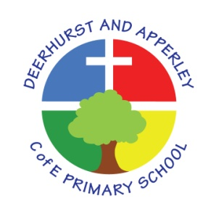

Subject: Geography
June 2022

Deerhurst and Apperley
Subject: Geography

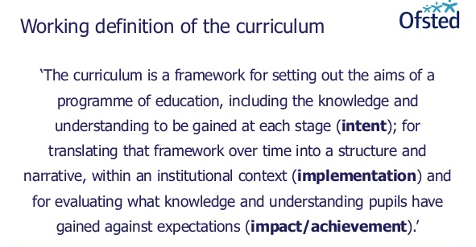

The Curriculum at Deerhurst and Apperley is:
Shaped by our vision: ‘Learning and living as children of God’. It is carefully thought out with opportunities and the intent to give the children a curriculum that will enable them to be the best they can be, like God wants the best for everyone.
The Curriculum at Deerhurst and Apperley is:
BALANCED: by promoting the intellectual, moral, spiritual aesthetic, creative emotional and physical development of each child. This intent is aligned to objectives in school and national policy objectives. Staff have a shared understanding of intent, implementation and impact and consistent teaching and marking methods are used (Implementation) to ensure impact on pupils.
RIGOROUS: the curriculum takes into account disciplinary habits of mind – disciplinary specific, powerful ways of thinking that are developed through sustained engagement with the discipline. For example, inverse operations in maths, cause and effect in science and provenance and context in history. This is all part of the implementation of the framework itself.
COHERENT: the curriculum is designed to promote the development of capabilities across subjects – for example, children learn about graphs in maths before it is needed in science. The design of our curriculum implementation will lead to impact through this coherence.
VERTICALLY INTEGRATED: it is clear how material taught in one year builds on what was learned in previous years, and how it leads on to subsequent learning. School clearly sets out the objectives each year and they are made clear at the implementation of the curriculum and the intent of how objectives will be transferred into processes, such as subject coverage, medium term plans and termly plans. The methods then developed in the classroom with objectives and marking will then reinforce implementation.
APPROPRIATE: the curriculum provides challenge for students when it is implemented and is planned for impact when study is ongoing or complete. That it meets the needs of all learners.
RELEVANT: the curriculum will be relevant and take into account the interest, needs and wishes of children, but within a framework of informed choice in respect of pedagogy and curriculum. School make clear objectives from national intent of the curriculum which are transferred clearly into implementation within school processes which lead to outcomes (Impact) of the school objectives and those of the children.

Subject Intent
It is our intent that the Geography curriculum at Deerhurst and Apperley Primary School arouses children’s curiosity about the natural and human aspects of the world around them, provoking questions and providing answers so that children develop a greater understanding and knowledge of the world and their place in it. The curriculum enables the children to develop knowledge and skills that are transferable to other curriculum areas and can be used to promote their spiritual, moral and cultural understanding as well as inspiring in them a curiosity and fascination about our world through the exploration of diverse places, people, resources and the natural and human environment, together with a deep understanding of the Earth’s key physical and human processes. The curriculum is designed to develop knowledge and skills that are progressive so that children know more, remember more and understand more.

Implementation
Geography at Deerhurst and Apperley is taught in blocks throughout the year to enable children to achieve depth in their learning. The key knowledge and skills for each block are identified on the long term planning which follows a two-year rolling programme. Each topic block is carefully thought through to ensure progression across a topic and between each milestone. Consideration is given to how greater depth will be taught, learned and demonstrated within each lesson as well as how learners will be supported in line with the school’s inclusion policy. Opportunities to revisit key skills so that they are ‘overlearned’ are also identified.
Rich learning experiences are specifically planned for across the school. These include:
- Cross-curricular links, particularly with English but also science and history
- Integrated tasks where the theme for the week has a strong geographical bias
- Use of the local environment, visitors and off-site visits

SMSC
Spiritual, Moral, Social and Cultural education is a natural focus of Geography as it involves the study of real people in real places and our relationship with the environment. It is developed in the following ways:

Spiritual | Inspiring awe and wonder of the natural world through the study of both its physical and human features
Moral | Examining the views held by society and the various groups within it through discussion, debate, role-play and decision-making activities
Social | Children work co-operatively in pairs and groups;
Cultural | Awareness of the cultural traditions of the place they are studying as well as our own multi-cultural society

Non-Negotiables
YEAR ONE | YEAR TWO | YEAR THREE | YEAR FOUR | YEAR FIVE | YEAR SIX
Pupils should know:  - The four seasons and their key characteristics  - The names of the four countries of the United Kingdom and their capital cities  - Simple ordnance survey map symbols related to the local area: road, school, river, church, houses  Key Vocabulary: weather; temperature; season; country; capital city; town; village; feature; symbol | Pupils should know:  - The names and locations of the seven continents  - The names and locations of the five oceans  - Where hot and cold places are in the world  - Key features of hot and cold places  - Differences in the climate and features of a contrasting non-European country to the UK  Key Vocabulary: continent; hemisphere; ocean; equator; north and south pole; population | Pupils should know:  - The names and key characteristics of climate zones: arid, Mediterranean, temperate, tropical, polar  - How to identify lines of latitude  - Names of the countries of North America: Canada; Costa Rica; Dominican Republic; Guatemala; Jamaica; Mexico; St Kitts and Nevis; St Lucia; USA  - The location of South America and its key features  - Key differences between South America and the UK  Key Vocabulary: climate; precipitation; landscape; human features; physical features; culture; trade | Pupils should know:  - The names of the world’s ten longest rivers  - The key features of a river system  - Names and location of the world’s rainforest  - Key characteristics of a rainforest  - The names of the 12 independent countries of South America: Argentina, Brazil, Bolivia, Chile, Colombia, Ecuador, Guyana, Paraguay, Peru, Suriname, Uruguay, Venezuela.  - How to locate and describe the position of features using four-figure grid references  Key Vocabulary: drainage; erosion; biome; ecosystem; biodiversity | Pupils should know:  - The names and locations of the world’s seven summits  - The structure of the Earth  - The names and locations of key volcanoes: Soufrière (St Lucia, North America), Eyjafjallajökul (Iceland, Europe), Popocatépetl (Mexico, North America), Vesuvius (Italy, Europe), St Helens (USA, North America), Etna (Italy, Europe).  - The names and locations of the principle countries of Europe  - Key characteristics of a chosen European country e.g. Greece  Key Vocabulary: dormant; epicenter; tsunami | Pupils should know:  - The names and locations of some of the UK’s major cities: Aberdeen, Belfast, Birmingham, Bristol, Cambridge, Cardiff, Edinburgh, Glasgow, Leeds, Liverpool, London, Manchester, Newcastle, Norwich, Nottingham, Oxford, Sheffield.  - The physical characteristics of the UK  - A wide range of ordnance survey symbols:  - How to locate and describe the position of features using six-figure grid references  Key Vocabulary: economy; industry; sustainable development

Impact
The impact of high quality-first teaching in geography will be seen in the following ways:
- Children demonstrate a genuine enthusiasm towards the subject, showing a real sense of curiosity to find out about the world and the people who live there.
- Children are able to describe where places are and what they look like using accurate geographical vocabulary appropriate to age
- Children have an understanding of the ways in which places are interdependent and interconnected and how much human and physical environments are interrelated.
- Children can interpret a range of geographical sources, including maps, globes and aerial photographs.
- Children can communicate information in a variety of ways including maps, numerical and quantitative skills and a range of literacy skills.
- Children understand, as responsible citizens, how they need to care and preserve the planet for future generations.
- Children transfer to KS3 effectively and successfully and will be well-prepared to continue and develop their geographical skills, knowledge and understanding

Monitoring and Evaluation
Monitoring and evaluation of geography teaching will follow the monitoring and evaluation schedule set out in the School Development Plan. The impact will be measured through the following methods:
- Observations of children
- Subject portfolios
- Pupil voice
- Subject assessment tracking (Milestones criteria)
- Annual reporting to parents
- Governor visits

This policy was created by Julie Oldroyd and presented and approved by governors at the meeting of XXX

Head teacher: Jayne Neveu Signed: Date:

Chair of Governors: Chris Davis Signed: Date

