Deerhurst and Apperley C of E Primary School

Learning and living as children of God
(Ephesians 5:1)(You are God’s children whom he loves. Try to be like God)

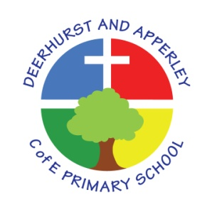

Music Subject Policy
June 2022

Deerhurst and Apperley
Music

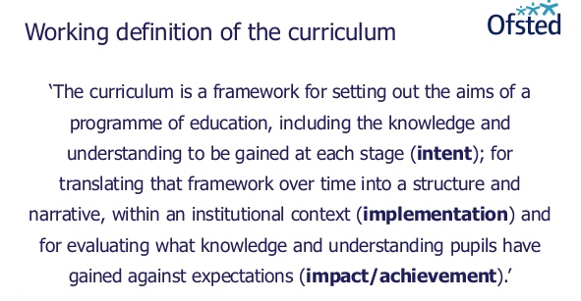

The Curriculum at Deerhurst and Apperley is:
Shaped by our vision: ‘Learning and living as children of God’. It is carefully thought out with opportunities and the intent to give the children a curriculum that will enable them to be the best they can be, like God wants the best for everyone.

The Curriculum at Deerhurst and Apperley is:

BALANCED: by promoting the intellectual, moral, spiritual aesthetic, creative emotional and physical development of each child. This intent is aligned to objectives in school and national policy objectives. Staff have a shared understanding of intent, implementation and impact and consistent teaching and marking methods are used (Implementation) to ensure impact on pupils.
RIGOROUS: the curriculum takes into account disciplinary habits of mind – disciplinary specific, powerful ways of thinking that are developed through sustained engagement with the discipline. For example, inverse operations in maths, cause and effect in science and provenance and context in history. This is all part of the implementation of the framework itself.
COHERENT: the curriculum is designed to promote the development of capabilities across subjects – for example, children learn about graphs in maths before it is needed in science. The design of our curriculum implementation will lead to impact through this coherence.
VERTICALLY INTEGRATED: it is clear how material taught in one year builds on what was learned in previous years, and how it leads on to subsequent learning. School clearly sets out the objectives each year and they are made clear at the implementation of the curriculum and the intent of how objectives will be transferred into processes, such as subject coverage, medium term plans and termly plans. The methods then developed in the classroom with objectives and marking will then reinforce implementation.
APPROPRIATE: the curriculum provides challenge for students when it is implemented and is planned for impact when study is ongoing or complete. That it meets the needs of all learners.
RELEVANT: the curriculum will be relevant and take into account the interest, needs and wishes of children, but within a framework of informed choice in respect of pedagogy and curriculum. School make clear objectives from national intent of the curriculum which are transferred clearly into implementation within school processes which lead to outcomes (Impact) of the school objectives and those of the children

Subject Intent

Music is integral to all aspects of our Mission Statement and school vision. This school believes that music contributes to the education of the whole person and promotes a love of learning. It is valued as a powerful and unique form of communication that can change the way pupils feel, think and act. It also increases self-discipline, creativity and fulfilment.

Our school uses the National Curriculum for music as the basis for its curriculum planning. While there are opportunities for children of all abilities to develop their skills and knowledge in each teaching unit, the progression planned into the scheme of work means that the children are increasingly challenged as they move through the school.

The National Curriculum for music aims to ensure that all pupils:
- perform, listen to, review and evaluate music across a range of historical periods, genres, styles and traditions, including the works of the great composers and musicians
- learn to sing and to use their voices, to create and compose music on their own and with others, have the opportunity to learn a musical instrument, use technology appropriately and have the opportunity to progress to the next level of musical excellence
- understand and explore how music is created, produced and communicated, including through the interrelated dimensions: pitch, duration, dynamics, tempo, timbre, texture, structure and appropriate musical notations

Our Music curriculum and wider opportunities allow our children to share their talents, as well as Christian faith and witness, with the wider community.

How is Music taught?

At Deerhurst and Apperley School, we make music an enjoyable learning experience. We encourage children to participate in a variety of musical experiences through which we aim to build up the confidence of all children. Singing lies at the heart of good music teaching. Our teaching focuses on developing the children’s ability to sing in tune and with other people. Through singing songs, children learn about the structure and organisation of music. We teach them to listen to and appreciate different forms of music. As children get older, we expect them to maintain their concentration for longer, and to listen to more extended pieces of music.

Children have the opportunity to work with a specialist music teacher for one term during the academic year learning an instrument. Class teachers work with music specialist during the sessions. In this way, the subject knowledge of teachers is developed, as well as their confidence in teaching music.

Additional music teaching

Children are offered the opportunity to study a musical instrument with peripatetic teachers. Peripatetic music teaching is provided by Mrs E Bennet. Parents who want their children to participate in the scheme must purchase or hire the instrument and pay the additional music lesson fees on a termly basis. These lessons are normally taught with children who have chosen to learn one of a variety of instruments, such as the clarinet and piano. This is in addition to the normal music teaching of the school, but usually takes place during curriculum time.

Music also has a very close link with the RE curriculum and with our prayer and worship provision. In addition to weekly curriculum Music lessons, singing and listening to music enriches whole school and class collective worship.

How is SMSC developed through music?

Spiritual | Give glory to God and celebrate faith through music and explore emotions through music
Moral | Explore moral issues through a range of listening, performance or composition
Social | Create a sense of community through music; share talents with the wider community
Cultural | Develop an understanding of the musical heritage of Great Britain and other cultures

Impact
Music is a universal language that embodies one of the highest forms of creativity as well as being truly inclusive musical activity that transcends all economical and academic boundaries and that it has a huge benefit on the wellbeing of our children.

As all pupils progress, they should develop critical engagement with music, allowing them to compose, and to listen with discrimination to the best in the musical canon. As well as discuss their learning with confidence. Music sessions are great opportunities to provide a cultural rich programme where resources or teacher support our SEN and vulnerable groups to achieve to the best of their ability. Equipment, resources and teacher support is differentiated when appropriate for children.

Children are given opportunities to demonstrate Building Learning Power such as
Resilience: Children will challenge themselves and when something is difficult they think about what they need to do to overcome the hurdle.
Resourcefulness: All teachers give lots of opportunities for children to ask questions and deepen their understanding. They are able to make links to developing confidence and links to school values (perseverance) and BLP (resilience).
Reflectiveness: Throughout the course of a unit children will think about what they have learnt in a lesson and record it.

In all lessons teachers model and demonstrate techniques which are then mirrored in their learning. Children are given the opportunity to demonstrate new skills to others or their music proficiency with their peers.

Monitoring and Evaluation

How is Music assessed?
Children demonstrate their ability in music in a variety of different ways. Teachers will assess children’s work in music by making informal judgements as they observe them during lessons. On completion of a piece of work, the teacher assesses the work and gives oral or written feedback as necessary to inform future progress. Older pupils are encouraged to make judgements about how they can improve their own work. At the end of a unit of work, class teachers record the attainment of pupils against the relevant National Curriculum objectives. Assessment outcomes are recorded each half term – children are judged to be either working towards, achieving expected standard or at greater depth.

How is Music monitored?
Music is monitored each term. This may take the form of discussions with pupils, gathering assessment data and evidence and observations as part of learning walks.

This policy was created by staff Kristina Robinson and presented and approved by governors at the meeting of 25th March 2020

Head teacher: Jayne Neveu Signed: Date:

Chair of Governors: Aaron Mulligan Signed: Date:

