Deerhurst and Apperley C of E Primary School

Learning and living as children of God
(Ephesians 5:1)(You are God’s children whom he loves. Try to be like God)

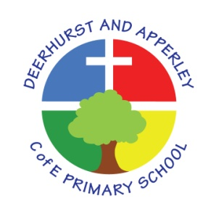

Mathematics Subject Policy
June 2022

Deerhurst and Apperley
Mathematics

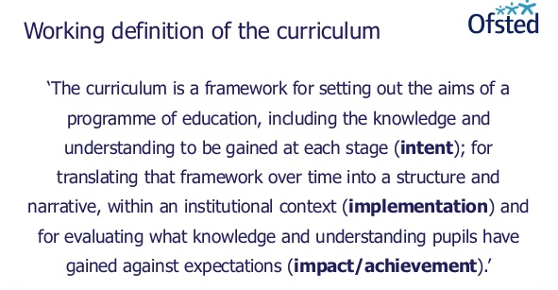

The Curriculum at Deerhurst and Apperley is:
Shaped by our vision: ‘Learning and living as children of God’. It is carefully thought out with opportunities and the intent to give the children a curriculum that will enable them to be the best they can be, like God wants the best for everyone.

The Curriculum at Deerhurst and Apperley is:

BALANCED: by promoting the intellectual, moral, spiritual aesthetic, creative emotional and physical development of each child. This intent is aligned to objectives in school and national policy objectives. Staff have a shared understanding of intent, implementation and impact and consistent teaching and marking methods are used (Implementation) to ensure impact on pupils.
RIGOROUS: the curriculum takes into account disciplinary habits of mind – disciplinary specific, powerful ways of thinking that are developed through sustained engagement with the discipline. For example, inverse operations in maths, cause and effect in science and provenance and context in history. This is all part of the implementation of the framework itself.
COHERENT: the curriculum is designed to promote the development of capabilities across subjects – for example, children learn about graphs in maths before it is needed in science. The design of our curriculum implementation will lead to impact through this coherence.
VERTICALLY INTEGRATED: it is clear how material taught in one year builds on what was learned in previous years, and how it leads on to subsequent learning. School clearly sets out the objectives each year and they are made clear at the implementation of the curriculum and the intent of how objectives will be transferred into processes, such as subject coverage, medium term plans and termly plans. The methods then developed in the classroom with objectives and marking will then reinforce implementation.
APPROPRIATE: the curriculum provides challenge for students when it is implemented and is planned for impact when study is ongoing or complete. That it meets the needs of all learners.
RELEVANT: the curriculum will be relevant and take into account the interest, needs and wishes of children, but within a framework of informed choice in respect of pedagogy and curriculum. School make clear objectives from national intent of the curriculum which are transferred clearly into implementation within school processes which lead to outcomes (Impact) of the school objectives and those of the children

Introduction
This document is a statement of the aims, principles and strategies for the teaching and learning of Mathematics at Deerhurst and Apperley C of E Primary School. Mathematics is a core subject and this policy has been written in accordance with its statutory requirements. All pupils can achieve in mathematics! At Deerhurst and Apperley C of E Primary School, it is our belief that pupils are not learning to be mathematicians but that they are mathematicians.
‘Mathematics is a creative and highly inter-connected discipline…a high-quality mathematics education should provide a foundation for understanding the world, the ability to reason mathematically, an appreciation of the beauty and power of mathematics, and a sense of enjoyment and curiosity.’ (National Curriculum for Mathematics, 2014)

Subject Intent

We aim to equip pupils with the tools to understand Maths. These tools include reasoning, problem solving and the ability to think in abstract ways. Mathematics is integral to all aspects of life; with this in mind, we strive to ensure that our children develop a healthy and enthusiastic attitude towards mathematics that will stay with them and support them in the next stage of their education and beyond. At each stage of learning, children are actively supported to reach their full potential as mathematicians.

The National Curriculum for mathematics aims to ensure that all pupils:
- become fluent in the fundamentals of mathematics, including through varied and frequent practice with increasingly complex problems over time, so that pupils develop conceptual understanding and the ability to recall and apply knowledge rapidly and accurately.
- reason mathematically by following a line of enquiry, conjecturing relationships and generalisations, and developing an argument, justification or proof using mathematical language
- can solve problems by applying their mathematics to a variety of routine and non- routine problems with increasing sophistication, including breaking down problems into a series of simpler steps and persevering in seeking solutions.

How is SMSC developed through Mathematics?

Spiritual | The study of mathematics enables students to make sense of the world around them and we strive to enable each of our students to explore the connections between their numeracy skills and every-day life. Developing deep thinking and an ability to question the way in which the world works promotes the spiritual growth of students. Students are encouraged to see the sequences, patterns, symmetry and scale both in the man-made and the natural world and to use maths as a tool to explore it more fully.
Moral | he moral development of students is an important thread running through the mathematics syllabus. Students are provided with opportunities to use their maths skills in real life contexts, applying and exploring the skills required in solving various problems. For example, students are encouraged to analyse data and consider the implications of misleading or biased statistical calculations. All students are made aware of the fact that the choices they make lead to various consequences. They must then make a choice that relates to the result they are looking for. The logical aspect of this relates strongly to the right/wrong responses in maths.
Social | Problem solving skills and teamwork are fundamental to mathematics through creative thinking, discussion, explaining and presenting ideas. Students are always encouraged to explain concepts to each other and support each other in their learning. In this manner, students realise their own strengths and feel a sense of achievement which often boosts confidence. Over time they become more independent and resilient learners.
Cultural | Mathematics is a universal language with a myriad of cultural inputs throughout the ages. Various approaches to mathematics from around the world are used and this provides an opportunity to discuss their origins. We try to develop an awareness of both the history of maths alongside the realisation that many topics we still learn today have travelled across the world and are used internationally.

Implementation

All teachers follow a termly overview plan and are encouraged to design lessons using a range of resources, including, but not limited to, the White Rose Maths Scheme of Learning from the White Rose Maths Hub. A typical Maths lesson provides the opportunity for all children, regardless of their ability, to become confident and capable learners. We are committed to building on prior learning and enabling our children to demonstrate a deep, conceptual understanding of each topic that they can develop over time. They are encouraged to develop fluency in their recall of key facts and a whole school approach to the teaching of calculation strategies is deployed across the school. This ensures a consistent and progressive approach and prepares our children for the upper key stage 2 curriculum. Reasoning and problem-solving skills are explicitly taught to enable children to become independent learners who are prepared to take risks. Additional time is allocated to arithmetic to ensure key skills in calculation are retained. The teaching of multiplication facts continues to be a discrete focus, where the applications of these skills are essential for accessing other areas of mathematics. To make the learning relevant, cross-curricular links are made wherever possible and children are encouraged to apply skills from all areas to complete real-life challenges and give learning a sense of purpose.

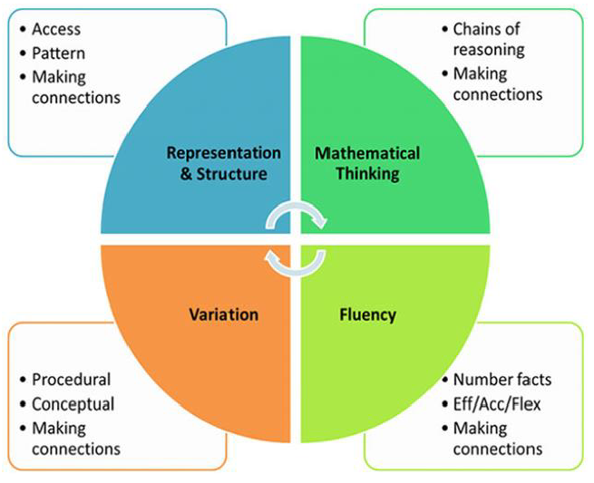

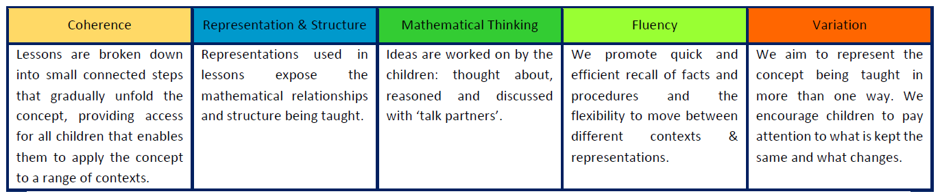

How is Mathematics taught?

To provide adequate time for developing key skills in fluency, reasoning and problem solving, each class teacher will provide at least five daily mathematics lessons per week. This may vary in length but will usually last for about 45 to 60 minutes. Additional mathematics may be taught within other subject lessons when appropriate.

Class teachers provide high quality maths lessons ensuring that there is emphasis on direct whole-year group teaching, groups/partner work and independent work. We use a range of approaches (concrete, pictorial and abstract methods) following the White Rose scheme of work, teaching mathematical concepts through small steps. Staff are expected to teach and model correct mathematical language, which scaffolds children’s reasoning and explanation skills – sentence stems are used to develop this.

Maths in Early Years
In the foundation stage they follow the White Rose Maths Schemes of learning. The Early Years is a time for exploration and investigation in maths and the learning environment promotes mathematical thinking. Children develop their understanding through a rich variety of activities both self-selected and adult led. Adults encourage the children to explore, enjoy, learn, practise and talk about their developing understanding which they can use to solve problems, generate questions and make connections across other areas of learning. They are introduced to Let’s Twist It questions to encourage children to explain why answers are right or wrong, this encourages them to deepen their learning.

Maths in Years 1 and 2
In Years 1 and 2, the focus of Maths is to ensure the children develop confidence and mental fluency with whole numbers, counting and place value. This often involves working with numerals, words and the four operations (+ - x ÷). The children should be precise in using and understanding place value and know number bonds to 20.
The children also develop their ability to recognise, describe, draw, compare and sort different shapes. The children will use a range of measures to describe and compare different quantities (such as length, mass, capacity/volume, time and money). From Year 1 onwards they follow our Do It, Twist It and Solve It questions types which encourages them to think and explain in a variety of different ways. In turn, this will help all children strive to deepen their understanding in maths and become confident mathematicians.
Our Y2 pupils are prepared for KS1 SATs
Maths in our Lower Key Stage 2 (Years 3 and 4)
In Years 3 and 4, the focus is to ensure the children become increasingly fluent with whole numbers and the four operations (including number facts and place value). Pupils begin to develop efficient written and mental calculations with increasingly large whole numbers. They begin to develop their ability to solve a range of problems, including simple fractions and decimal place value. The children develop mathematical reasoning to help them analyse shapes and their properties and confidently describe their relationships.
By the end of Year 4, children should have memorised their multiplication tables up to and including the 12 times table and be able to show precision and fluency in their work.
Pupils in Year 4 are prepared for the Multiplication Tables Check (MTC), from 2020 onwards.

Maths in our Upper Key Stage 2 (Years 5 and 6)
In Years 5 and 6, the focus of Maths is to ensure that children extend their understanding of the number system and place value to include larger integers. Pupils should be able to make connections between multiplication and division with fractions, decimals, percentages and ratio. Children should develop their ability to solve a wider range of problems, including increasingly complex properties of numbers and arithmetic, and problems that demand the use of efficient written and mental methods of calculation. Children are introduced to algebra as a means for solving a variety of problems.
The children’s understanding and knowledge in geometry and measures consolidates and extends the knowledge they have developed in number; children should be able to classify shapes with increasingly complex geometric properties, using the vocabulary they need to describe them with accuracy and confidence.
Our Y6 pupils are prepared for KS2 SATs.

Impact

The impact of our Maths curriculum is that our pupils achieve and make progress in line with other pupils nationally, evident through:
➢ Fluency in their recall of key number facts and procedures
➢ Accuracy in the formal calculation methods for all four operations
➢ The flexibility and fluidity to move between different contexts and representations of mathematics.
➢ The ability to recognise relationships and make connections in mathematics
➢ The confidence and resilience to reason mathematically and solve a range of problems.

SEN Children

Children with additional needs are supported by using practical resources and differentiated activities where needed. They are also further supported by additional support staff whenever possible. Where applicable, children’s provision maps will incorporate suitable objectives from the National Curriculum or the EYFS curriculum and teachers keep these objectives in mind when planning work. In addition to quality first teaching, interventions also take place during the afternoons and focus on those children who may need more specific targeted input.
Assessment, Recording and Reporting to parents
Monitoring and Evaluation
Assessment is an integral part of the maths curriculum and not an addition to it. Children’s work in mathematics is assessed from three aspects:
1)Informal, formative assessments are made continually by questioning the children, observing and monitoring their work. These short term assessments are closely related to the learning objectives for the lesson and help inform next steps.
2)Summative assessments take place at the end of a term – we use white rose maths end of term assessments to check progress and understanding of content covered. This information also informs interventions.

Statutory Assessment Tests (SATs) are used for children in Year 2 and 6, plus children in Year 4 are also required to take a multiplication tables check (MTC) in the Summer Term. The purpose of the check is to determine whether pupils can fluently recall their times tables up to 12, which is essential for future success in mathematics.

A whole school tracking system is used to closely monitor children’s progress throughout the school. Teacher assessments are entered termly and are closely analysed to identify children working at greater depth or who are at risk, appropriate intervention is then put in place to close gaps.

Rachel Hoarau, govener, attends to look at Mathematics for a governor visit. In this meeting, we look at books and an overview of mathematics across the whole school.

This policy was created by Nicole Rimmer and presented and approved by governors at the meeting of 13th July 2022

Head teacher: Jayne Neveu Signed: Date:

Chair of Governors: Chris Davis Signed: Date:

