Deerhurst and Apperley C of E Primary School

Learning and living as children of God
(Ephesians 5:1)(You are God’s children whom he loves. Try to be like God)

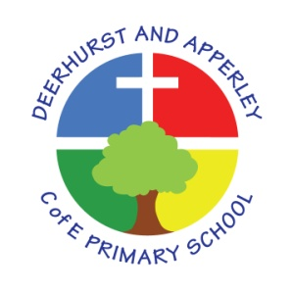

Design Technology (DT) Subject Policy
June 2022

Deerhurst and Apperley
Design Technology

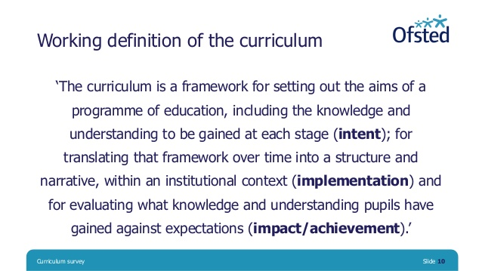

The Curriculum at Deerhurst and Apperley is:
Shaped by our vision: ‘Learning and living as children of God’. It is carefully thought out with opportunities and the intent to give the children a curriculum that will enable them to be the best they can be, like God wants the best for everyone.

The Curriculum at Deerhurst and Apperley is:

BALANCED: by promoting the intellectual, moral, spiritual aesthetic, creative emotional and physical development of each child. This intent is aligned to objectives in school and national policy objectives. Staff have a shared understanding of intent, implementation and impact and consistent teaching and marking methods are used (Implementation) to ensure impact on pupils.
RIGOROUS: the curriculum takes into account disciplinary habits of mind – disciplinary specific, powerful ways of thinking that are developed through sustained engagement with the discipline. For example, inverse operations in maths, cause and effect in science and provenance and context in history. This is all part of the implementation of the framework itself.
COHERENT: the curriculum is designed to promote the development of capabilities across subjects – for example, children learn about graphs in maths before it is needed in science. The design of our curriculum implementation will lead to impact through this coherence.
VERTICALLY INTEGRATED: it is clear how material taught in one year builds on what was learned in previous years, and how it leads on to subsequent learning. School clearly sets out the objectives each year and they are made clear at the implementation of the curriculum and the intent of how objectives will be transferred into processes, such as subject coverage, medium term plans and termly plans. The methods then developed in the classroom with objectives and marking will then reinforce implementation.
APPROPRIATE: the curriculum provides challenge for students when it is implemented and is planned for impact when study is ongoing or complete. That it meets the needs of all learners.
RELEVANT: the curriculum will be relevant and take into account the interest, needs and wishes of children, but within a framework of informed choice in respect of pedagogy and curriculum. School make clear objectives from national intent of the curriculum which are transferred clearly into implementation within school processes which lead to outcomes (Impact) of the school objectives and those of the children

Subject Intent

Music is integral to all aspects of our Mission Statement and school vision. This school believes that music contributes to the education of the whole person and promotes a love of learning. It is valued as a powerful and unique form of communication that can change the way pupils feel, think and act. It also increases self-discipline, creativity and fulfilment.

Our school uses the National Curriculum for music as the basis for its curriculum planning. While there are opportunities for children of all abilities to develop their skills and knowledge in each teaching unit, the progression planned into the scheme of work means that the children are increasingly challenged as they move through the school.

The National Curriculum for music aims to ensure that all pupils:
- perform, listen to, review and evaluate music across a range of historical periods, genres, styles and traditions, including the works of the great composers and musicians
- learn to sing and to use their voices, to create and compose music on their own and with others, have the opportunity to learn a musical instrument, use technology appropriately and have the opportunity to progress to the next level of musical excellence
- understand and explore how music is created, produced and communicated, including through the interrelated dimensions: pitch, duration, dynamics, tempo, timbre, texture, structure and appropriate musical notations

Our Music curriculum and wider opportunities allow our children to share their talents, as well as Christian faith and witness, with the wider community.

Subject Intent

Our aim is that our Design and Technology (DT) curriculum equips our children with the knowledge and understanding to be active participants in a rapidly changing world. We hope that through developing creative thinking, our children will acquire the skills needed to make positive changes to society for the good of all, so that they can ‘care for our community as neighbours’. Our curricular provision encourages children to become autonomous and creative problem-solvers, both as individuals and as part of a team. It enables them to identify needs and opportunities and to respond by developing ideas, and eventually making products and systems.

The National Curriculum for DT aims to ensure that all pupils:

- develop the creative, technical and practical expertise needed to perform everyday tasks confidently and to participate successfully in an increasingly technological world
- build and apply a repertoire of knowledge, understanding and skills in order to design and make high-quality prototypes and products for a wide range of users
- critique, evaluate and test their ideas and products and the work of others
- understand and apply the principles of nutrition and learn how to cook

How is DT taught?

Teachers ensure that the children apply their knowledge and understanding when developing ideas, planning and making products, and then evaluating them. Six, interrelated principles describe the features of a genuine D&T experience from the pupils’ perspective and can be applied to all material areas and aspects of the subject. Each principle should be evident to a greater or lesser degree in each project that pupils undertake.
- User
- Purpose
- Functionality
- Design Decisions
- Innovation
- Authenticity
We do this through a mixture of whole-class teaching and individual or group activities. Within lessons, we give children the opportunity both to work on their own and to collaborate with others, listening to other children’s ideas and treating these with respect. Children critically evaluate existing products, their own work and that of others.
Designing - Understanding contexts, users and purposes
Designing - Generating, developing, modelling and communicating ideas
Making - Planning
Making - Practical skills and techniques
Technical knowledge - Making products work
Evaluating - Own ideas and products
Evaluating - Existing products
Cooking and nutrition - Where food comes from
Cooking and nutrition - Food preparation, cooking, and nutrition
Technical knowledge - Making products work

How is SMSC developed through art?

Spiritual | Explore creativity through design
Moral | Encourage respect for others and their work
Social | Promote a sense of community
Cultural | Appreciate how culture influences design

Impact

At Deerhurst and Apperley, using creativity and imagination, pupils design and make products that solve real and relevant problems within a variety of contexts, considering their own and others’ needs, wants and values. They acquire a broad range of subject
knowledge and draw on disciplines such as mathematics, science, engineering, computing and art. Pupils learn how to take risks, becoming resourceful, innovative, enterprising
and capable citizens. Through the evaluation of past and present design and technology, they develop a critical understanding of its impact on daily life and the wider world.
High-quality design and technology education makes an essential contribution to the creativity, culture, wealth and wellbeing of the nation.

Children are given opportunities to demonstrate Building Learning Power such as
Resilience: Children will challenge themselves and when something is difficult they think about what they need to do to overcome the hurdle.
Resourcefulness: All teachers give lots of opportunities for children to ask questions and deepen their understanding. They are able to make links to developing confidence and links to school values (perseverance) and BLP (resilience).
Reflectiveness: Throughout the course of a unit children will think about what they have learnt in a lesson and record it.

In all lessons teachers’ model and demonstrate techniques which are then mirrored in their learning. Children are given the opportunity to demonstrate new skills and exhibit their creativity and work to others.

Monitoring and Evaluation

How is DT assessed?

We assess the children’s work in Design Technology while observing them working during lessons. Teachers record the attainment of pupils against the relevant National Curriculum objectives set out on the School DT Assessment Framework. Assessment outcomes are recorded each term – children are judged to be either working towards, achieving expected standard or at greater depth. Children are encouraged to assess and evaluate both their own work and that of other pupils. This helps them to appreciate how they can improve their performance, and what their targets should be for the future.

How is DT monitored?

Design Technology is monitored each term. This may take the form of discussions with pupils, scrutiny of work, gathering assessment data and evidence and observations as part of learning walks.

This policy was created by staff Kristina Robinson and presented and approved by governors at the meeting of July 2022

Head teacher: Jayne Neveu Signed: Date:

Chair of Governors: Signed: Date:

