Deerhurst and Apperley C of E Primary School

Learning and living as children of God
(Ephesians 5:1)(You are God’s children whom he loves. Try to be like God)

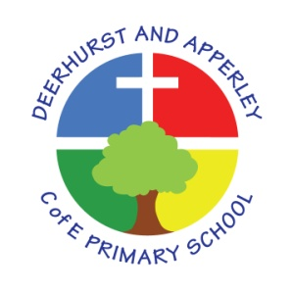

Art Subject Policy
June 2022

Deerhurst and Apperley
Subject

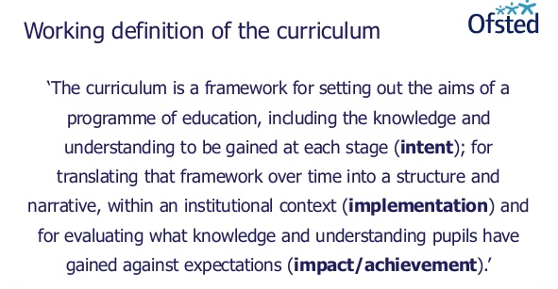

The Curriculum at Deerhurst and Apperley is:
Shaped by our vision: ‘Learning and living as children of God’. It is carefully thought out with opportunities and the intent to give the children a curriculum that will enable them to be the best they can be, like God wants the best for everyone.

The Curriculum at Deerhurst and Apperley is:

BALANCED: by promoting the intellectual, moral, spiritual aesthetic, creative emotional and physical development of each child. This intent is aligned to objectives in school and national policy objectives. Staff have a shared understanding of intent, implementation and impact and consistent teaching and marking methods are used (Implementation) to ensure impact on pupils.
RIGOROUS: the curriculum takes into account disciplinary habits of mind – disciplinary specific, powerful ways of thinking that are developed through sustained engagement with the discipline. For example, inverse operations in maths, cause and effect in science and provenance and context in history. This is all part of the implementation of the framework itself.
COHERENT: the curriculum is designed to promote the development of capabilities across subjects – for example, children learn about graphs in maths before it is needed in science. The design of our curriculum implementation will lead to impact through this coherence.
VERTICALLY INTEGRATED: it is clear how material taught in one year builds on what was learned in previous years, and how it leads on to subsequent learning. School clearly sets out the objectives each year and they are made clear at the implementation of the curriculum and the intent of how objectives will be transferred into processes, such as subject coverage, medium term plans and termly plans. The methods then developed in the classroom with objectives and marking will then reinforce implementation.
APPROPRIATE: the curriculum provides challenge for students when it is implemented and is planned for impact when study is ongoing or complete. That it meets the needs of all learners.
RELEVANT: the curriculum will be relevant and take into account the interest, needs and wishes of children, but within a framework of informed choice in respect of pedagogy and curriculum. School make clear objectives from national intent of the curriculum which are transferred clearly into implementation within school processes which lead to outcomes (Impact) of the school objectives and those of the children

Subject Intent

Our Art and Design curriculum stimulates a love of learning, creativity and imagination, providing visual, tactile and sensory experiences, which enable our children to understand and respond to local and wider international community. Through Art and Design, our children are given opportunities to communicate what they see, feel and think, through the use of colour, texture, form, pattern and different materials and processes. They are able to explore ideas and meanings, including those in religious images and representations, through the work of artists and designers. Through learning about the roles and functions of art, they can explore the impact it has had on contemporary life and on different periods and cultures. The appreciation and enjoyment of the visual arts enrich all our lives.

The National Curriculum for art aims to ensure that all pupils:
- produce creative work, exploring their ideas and recording their experiences
- become proficient in drawing, painting, sculpture and other art, craft and design techniques
- evaluate and analyse creative works using the language of art, craft and design
- know about great artists, craft makers and designers, and understand the historical and cultural development of their art forms.

Our Art curriculum and wider opportunities allow our children to share their talents, as well as Christian faith and witness, with the wider community.

How is Art taught?

Art and Design is taught through a mixture of whole-class teaching and individual or group activities. Children are encouraged to evaluate their own ideas and methods, and the work of others, and to say what they think and feel about them. We give children the opportunity to work by themselves and in collaboration with others, on projects in two and three dimensions, and at different scales. Skills are taught discretely and then applied in focussed activities or through cross-curricular applications. The Key skills taught include appreciation of works of art, exploring and evaluating ideas, drawing, digital media, 3D design, painting, printing, textiles and collage.

Topic links are made where appropriate. Key skills are taught to develop a good level of understanding and are then applied through class topics. Meaningful links have previously been made with History, Geography, Computing, Maths and English. Art also has a close link with the RE curriculum and with our prayer and worship provision.

How is SMSC developed through art?

Spiritual | Promotes self-esteem and explore creativity and imagination
Moral | Explore moral issues through discussions about works of art
Social | Promote collaborative learning and celebrate children’s achievements through the display of art work
Cultural | Explore art from different cultures, including that of Great Britain, to stimulate discussion

Impact

At Deerhurst and Apperley, we believe that quality art, craft and design education provides and inspires personal expression, cultural understanding, creative and practical responses, promoting imaginative risk taking to provide solutions to our material, emotional, social and virtual worlds. This will enable pupils to contribute as confident citizens and future professionals to the culture, creativity, economic success, leisure, material and emotional wellbeing of our society within both national and global contexts.

As pupils progress, they should be able to think critically and develop a more rigorous understanding of art and design. They should also know how art and design both reflect and shape our history, and contribute to the culture, creativity and wealth of our nation. Art sessions are great opportunities to provide a cultural rich programme where resources or teacher support our SEN and vulnerable groups to achieve to the best of their ability. Equipment, resources and teacher support is differentiated when appropriate for children.

Children are given opportunities to demonstrate Building Learning Power such as
Resilience: Children will challenge themselves and when something is difficult they think about what they need to do to overcome the hurdle.
Resourcefulness: All teachers give lots of opportunities for children to ask questions and deepen their understanding. They are able to make links to developing confidence and links to school values (perseverance) and BLP (resilience).
Reflectiveness: Throughout the course of a unit children will think about what they have learnt in a lesson and record it.

In all lessons teachers’ model and demonstrate techniques which are then mirrored in their learning. Children are given the opportunity to demonstrate new skills and exhibit their creativity and work to others.

Monitoring and Evaluation

How is Art assessed?

We assess the children’s work in Art and Design while observing them working during lessons. Teachers record the attainment of pupils against the relevant National Curriculum objectives set out on the School Art Assessment Framework. Assessment outcomes are recorded each term – children are judged to be either working towards, achieving expected standard or at greater depth.
Children are encouraged to assess and evaluate both their own work and that of other pupils. This helps them to appreciate how they can improve their performance, and what their targets should be for the future.

How is Art monitored?

Art is monitored each half term. This may take the form of discussions with pupils, scrutiny of work, gathering assessment data and evidence and observations as part of learning walks.

This policy was created by staff Kristina Robinson and presented and approved by governors at the meeting of 25th March 2020

Head teacher: Jayne Neveu Signed: Date:

Chair of Governors: Signed: Date:

