Deerhurst and Apperley C of E Primary School

Learning and living as children of God
(Ephesians 5:1)(You are God’s children whom he loves. Try to be like God)

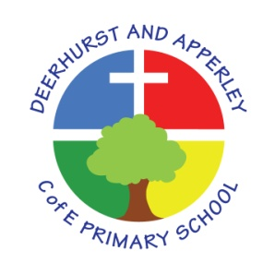

Subject: Computing
June 2022

Deerhurst and Apperley
Subject: Computing

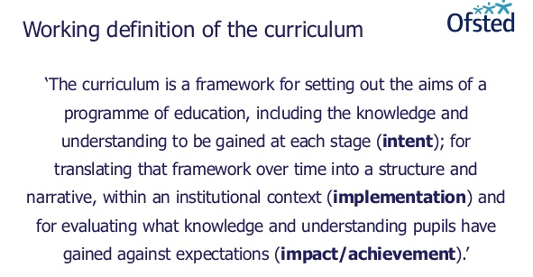

The Curriculum at Deerhurst and Apperley is:
Shaped by our vision: ‘Learning and living as children of God’. It is carefully thought out with opportunities and the intent to give the children a curriculum that will enable them to be the best they can be, like God wants the best for everyone.
The Curriculum at Deerhurst and Apperley is:
BALANCED: by promoting the intellectual, moral, spiritual aesthetic, creative emotional and physical development of each child. This intent is aligned to objectives in school and national policy objectives. Staff have a shared understanding of intent, implementation and impact and consistent teaching and marking methods are used (Implementation) to ensure impact on pupils.
RIGOROUS: the curriculum takes into account disciplinary habits of mind – disciplinary specific, powerful ways of thinking that are developed through sustained engagement with the discipline. For example, inverse operations in maths, cause and effect in science and provenance and context in history. This is all part of the implementation of the framework itself.
COHERENT: the curriculum is designed to promote the development of capabilities across subjects – for example, children learn about graphs in maths before it is needed in science. The design of our curriculum implementation will lead to impact through this coherence.
VERTICALLY INTEGRATED: it is clear how material taught in one year builds on what was learned in previous years, and how it leads on to subsequent learning. School clearly sets out the objectives each year and they are made clear at the implementation of the curriculum and the intent of how objectives will be transferred into processes, such as subject coverage, medium term plans and termly plans. The methods then developed in the classroom with objectives and marking will then reinforce implementation.
APPROPRIATE: the curriculum provides challenge for students when it is implemented and is planned for impact when study is ongoing or complete. That it meets the needs of all learners.
RELEVANT: the curriculum will be relevant and take into account the interest, needs and wishes of children, but within a framework of informed choice in respect of pedagogy and curriculum. School make clear objectives from national intent of the curriculum which are transferred clearly into implementation within school processes which lead to outcomes (Impact) of the school objectives and those of the children.

Subject Intent
The intention of the computing curriculum at Deerhurst and Apperley is that all children are able to thrive as responsible, digital citizens. Technology is everywhere and will play a pivotal part in our pupils’ lives, therefore, we aim to model and educate them on how to use technology positively and safely. It is our intention that pupils become confident and competent users of a range of technologies and our broad computing curriculum includes computer science, information technology and online safety. All staff are encouraged to embed computing across the whole curriculum to make learning creative and accessible, recognising that technology can allow pupils to share their learning in creative ways. We also understand the accessibility opportunities technology can provide for our SEN pupils. By the end of Key Stage 2, it is our intention that all children be flexible, creative, responsible and confident users of technology who are able to choose the best tools to fulfil the task and challenges set by teachers and that the knowledge and skills they have developed have prepared them for the Key Stage 3 computing curriculum.

Implementation
Our computing curriculum is shaped by our intention that all children regardless of background, ability, additional needs, flourish to become the very best version of themselves they can possibly be. At Deerhust and Apperley, we follow the National Curriculum for Computing, covering the three strands of computer science, information technology and digital literacy. Because of our mixed-age classes, our units of work are bespoke to each class and build on previously learned skills to ensure children know more, remember more and understand more so that they are able to apply their learning to a variety of contexts. Our units of work are derived from a variety of sources including:
- Rising Stars Switched On Computing
- Barefoot computing resources
- Code.org
- Hour of Code
- Code-it.co.uk
The units of work are underpinned by a clear skills progression in the strands of computer science and information technology. All KS1 and KS2 classes teach units in the following areas across two years:
- Word processing, including the use and manipulation of pictures
- Data handling
- Programming – on-screen or physical
In addition to this, every class takes part in the annual international Safer Internet Day held each February and continue to have a discrete internet safety lesson each term i.e. six in total using the resources produced by SWGFL though it is recognised that some of these materials are looking dated so the school will begin to use the Project Evolve materials from January 2021. Planning will be updated to reflect the new units following staff discussion at INSET day.

Although each class has a regularly timetabled computing session, the majority of our computing is embedded across the curriculum in order to provide meaningful contexts for teaching and learning. Children are taught sequential skills in lessons which build towards a final outcome over a series of sessions. They are given regular opportunities to practise and apply previously learned skills in all areas of the curriculum.

SMSC
SMSC is developed in the Computing curriculum in the following ways:

Spiritual | Reflecting on the current opportunities that have been created through computing, as well as future potential and their place in this future.
Moral | Recognising the difference between right and wrong and the ethical use of the internet e.g. cyberbullying
Social | Working collaboratively to share ideas and skills
Cultural | Preparing children for the challenges of living and learning in a technologically enriched and increasingly interconnected world.
Non-Negotiables

YEAR ONE | YEAR TWO | YEAR THREE | YEAR FOUR | YEAR FIVE | YEAR SIX
Children can:  - Use a keyboard to type and edit text  - Use appropriate shapes, paint tools and colour to create a picture  - Programme a floor robot (Beebot) to follow a sequence of movements: forwards, backwards, left, right  - Add programming blocks to a sprite to give it instructions for moving on screen | Children can:  - Use tools to change a photograph  - Programme a floor robot (Beebot) to move around a maze (mat), debugging algorithms when needed  - Programme a sprite to perform a variety of actions on screen: move up, down, left, right; turn right/left; change speed; grow; shrink; hide; say | Children can:  - Combine text and images into a suitable layout for a given purpose  - Animate a sequence of images  - Write a programme that includes sequences, sprites with costumes, and multiple backdrops.  - Use ‘event, ‘motion’ and ‘pen’ blocks to programme a sprite | Children can:  - Change digital images by recolouring, cloning and combining  - Edit audio recordings and layer sounds  - Use count controlled loops (repetition) to produce a given outcome  - Create games in which two or more loops run at the same time – count-controlled and infinite | Children can:  - Use video editing software to improve a video  - Use tools to achieve the desired effect in vector drawings  - Use ‘if . . .then’ (selection) to direct the flow of a programme in physical computing  - Use ‘if . . . then . . . else’ (selection) to direct the flow of a programme on screen | Children can:  - Construct 3D models of physical objects  - Use formula for calculating data  - Use variables to simulate a scoreboard  - Combine sequence, repetition, selection and variables to programme a micro:bit

Impact
The impact of high quality-first teaching in computing will be seen in the following ways:
- Children demonstrate a genuine enthusiasm towards computing
- Children’s increasing confidence in applying their computing skills to a variety of situations
- Children are able to identify the source of problems and work with perseverance to ‘debug’ them.
- Children are able to articulate clearly the potential risks of being online and can talk about ways to keep safe
- Children are able to create and evaluate their own project work.
- Children will transfer to KS3 effectively and successfully and will be well-prepared to continue and develop their computing skills
Monitoring and Evaluation
Monitoring and evaluation of computing teaching will follow the monitoring and evaluation schedule set out in the School Development Plan. The impact will be measured through the following methods:
- Observations of children
- Subject portfolios
- Pupil voice
- Subject assessment tracking (Milestones criteria)
- Annual reporting to parents
- Governor visits

This policy was created by Julie Oldroyd and presented and approved by governors at the meeting of July 2022

Head teacher: Jayne Neveu Signed: Date:

Chair of Governors: Chris Davis Sign

