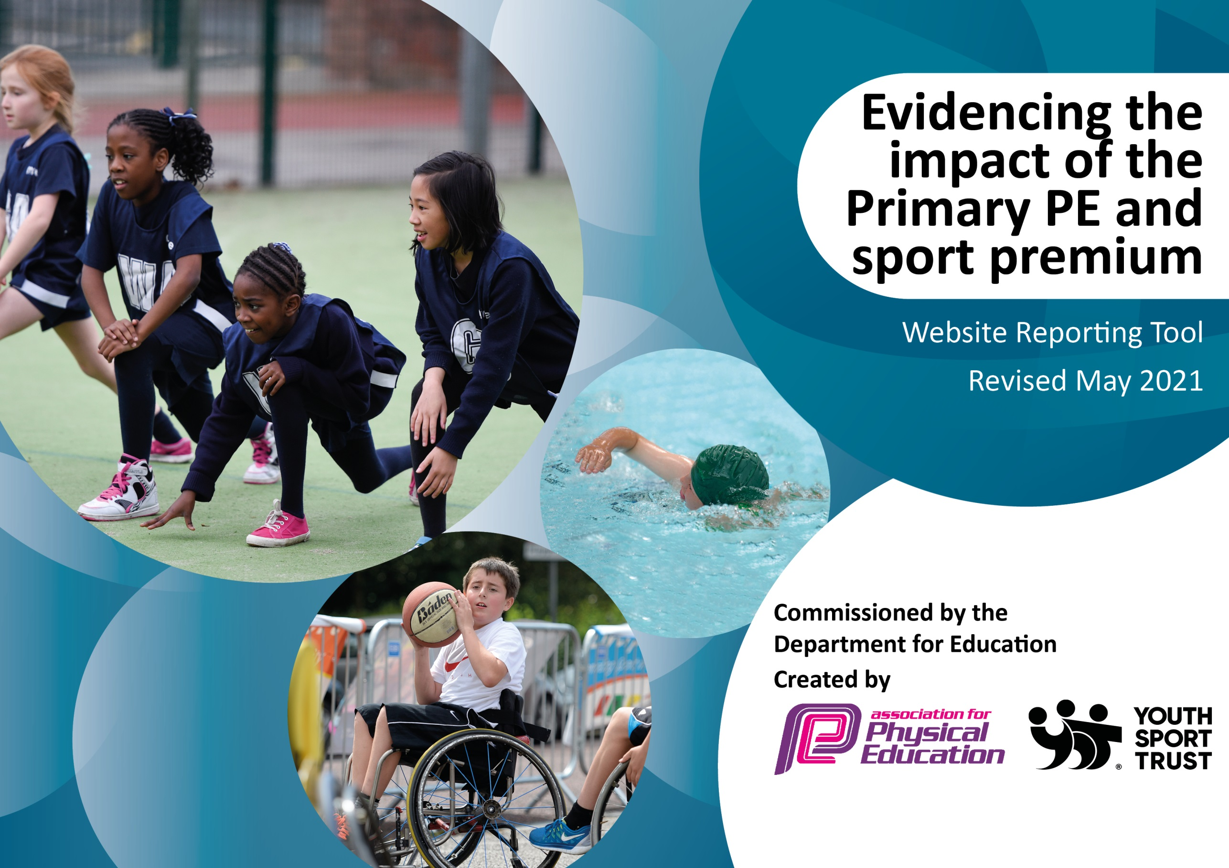
Sport Premium 2021-2022 Intent– 3rd edition- template – with updated impact year end July 2022

Support for review and reflection - considering the 5 key indicators from DfE, what development needs are a priority for your setting and your pupils now and why? Use the space below to reflect on previous spend and key achievements and areas for development.
Key achievements to date until July 2021: | Areas for further improvement and baseline evidence of need:
- Many children throughout school engage in regular physical activity. Clubs are offered at lunch time & after school, many children attend one or more of these clubs. All children have at least 2 hours of PE every week and are active throughout these lessons and demonstrate a good level of fitness.  - !00% engagement of online PE activities including mindfulness and live teacher lead yoga throughout lockdown Spring 2021  - . The profile of PE & Sport is high throughout the school. Sporting achievement and involvement is celebrated at Parent Celebration assemblies and the school newsletter. Children enjoy representing the school at sports festivals and competitions. School took part in virtual competitions during 2020-21  - Forthcoming PE activities/CPD are shared so that staff feel confident delivering lessons when the PE specialist is out of school. CPD is organised according to those areas identified by the staff. All staff had CPD this year with the Box 2 B fit coach, Rugby and shadowing our PE specialist.  - A variety of equipment has been purchased to allow teaching a broader range of sports during the children’s PE lessons and at extra-curricular clubs. In particular relating to mindfulness, mats, music, staking systems.  - Sports coaches/instructors have been brought in to deliver extra activities, eg Cricket summer 2021, Rugby 2021 CPD  - The School Games competition format is fully embraced. At level 1 intra house competitions take place regularly. At level 2 the school enters most competitions offered by Move More in collaboration with  - To date the school has achieved three Gold School Sports Awards. The Gold award for 2019 has been extended to cover 2020 and 2021 due to COVID-19.  - School Sports Blog is regularly maintained with all events | Deerhurst and Apperley Primary School will achieve this overview by:  • Continue with high profile of mental and physical health and well-being in  light of COVID-19 implications  • Continuing to employ an experienced specialist sports teacher to support  the teaching of PE & Sport and to provide professional development to all  staff& coordinate and expand extra-curricular PE in school.  • Book dance and fitness classes as these were ,issed due to COVID)  • Forest School opportunities for all school (staff training) – linked to health and well being  • Health and well-being opportunities to raise profile of mental health and  how that links to physical activity  • Continuing to improve resources in school for delivering high quality PE.  • Developing healthy lifestyles through increased opportunities.  • Improving physical levels during lunchtimes  • Continue with The Daily Mile for all children  • Increasing school sports opportunities within school time and after school  clubs  • Increase awareness of nutrition and the impact on healthy lifestyles ( link  to mental health drive)  • Engage parents on the importance of healthy snacks – using Facts for Life etc  • Increase awareness on mental well-being and the impact on health by  having a dedicated session for outdoor learning and developing deeper  understanding of online safety  • Continue to replace storage and equipment that is old and worn, that is  above and beyond school budget  • Consider new playground markings  • Y6 children will be able to swim 25 metres by the end of Y6 if needed  money will be directed outside of curriculum requirements (Heidi’s heroes  - use dance and game-based activities to refine pupils' movement (part of teaching a broad and balanced curriculum for education recovery document July 2021)

Total amount carried forward from underspend 2020-21 £42

Sport Premium Intent, Implementation and Impact 2021-22Deerhurst and Apperley C of E School
Mrs Jayne Neveu (Headteacher (see previous amended templates 2019-20 – 2020-21)

This year, once again, Deerhurst and Apperley applied for the School Sports award Gold Standard. due to COVID 19 the further application for the award was cancelled again and our current Gold Award maintained. We believe that sport not only contributes to the physical development of pupils but also makes a significant contribution to pupils’ personal wellbeing and enjoyment of school. We look to inspire and engage children’s interest in sporting activities through providing a wide range of opportunities within school, after school and within the wider community. We look to foster children’s interest in physical wellbeing and healthy lifestyles in order to establish long lasting lifestyle messages. Furthermore, at Deerhurst we look to promote our Christian values through sports and positively encourage all children to take part in opportunities. We are proud of the PE curriculum and sporting opportunities that we offer. Our children have the opportunity to experience and gain skills in a wide variety of individual and team sports.
Through our learning community we participate in swimming galas, tag rugby, football, netball and rounders tournaments as well as inter school festivals, for example, football festivals for KS1. Although, in the Aut 2020 some of our competitions were organised virtually but some were alas postponed.. We also hold a successful competitive Sports Day during the Summer Term; the Sports Trophy is awarded to the winning house team at our final celebration assembly. Once again this year our Sport Leaders will run our Sports Day 2022 as Summer 2021 they were able to run it but parents did not attend the live event. This was sent out via a link. We also award trophies to best Sports Girl and Best Sports Boy annually and these achievements can be seen recorded in our School Awards Book. Through residential visits in years 5 and 6, children are able to take part in outdoor activity challenges such as archery, abseiling, dragon boat racing & trapeze.

We also have consistently good links with Cheltenham Town Football Club to provide after school activities, Apperley/Glos Cricket Club to provide cricket and we remain members of Move More organisation to allow us to work with other schools and have opportunities to CPD

Meeting national curriculum requirements for swimming and water safety.  N.B Complete this section to your best ability. For example you might have practised safe self-rescue techniques on dry land which you can transfer to the pool when school swimming restarts.  Due to exceptional circumstances priority should be given to ensuring that pupils can perform safe self rescue even  if they do not fully meet the first two requirements of the NC programme of study. | Y6 swim summer summer 2022
What percentage of your current Year 6 cohort swim competently, confidently and proficiently over a distance of at least 25 metres? | 91%
What percentage of your current Year 6 cohort use a range of strokes effectively [for example, front crawl, backstroke and breaststroke]?  Please see note above. | 82%
What percentage of your current Year 6 cohort perform safe self-rescue in different water-based situations? | 82%
Schools can choose to use the Primary PE and sport premium to provide additional provision for swimming but this must be for activity over and above the national curriculum requirements. Have you used it in this way? | Yes/No

Action Plan and Budget Tracking
Capture your intended annual spend against the 5 key indicators. Clarify the success criteria and evidence of impact that you intend to measure to evaluate for pupils today and for the future.

Academic Year: 2021-22 | Total fund allocated: £16,740 | Date Updated for September 2021
Key indicator 1: The engagement of all pupils in regular physical activity – Chief Medical Officers guidelines recommend that primary school pupils undertake at least 30 minutes of physical activity a day in school |  |  |  | Percentage of total allocation:
 |  |  |  | 78%
Intent | Implementation |  | Impact end July 2022 | £13,100
Your school focus should be clear what you want the pupils to know and be able to do and about  what they need to learn and to  consolidate through practice: | Make sure your actions to achieve are linked to your intentions: | Funding allocated(approx) | Evidence of impact: what do pupils now know and what can they now do? What has changed?: | Sustainability and suggested next steps:
All children to be physically active for at least 30 minutes a day everyday. This will also include Go noodle/ dough disco etc  Engage children in after school clubs on a more regular basis (subject to any COVID restrictions)  Give all children the continued opportunity for mindfulness in view of recent restrictions due to COVID  To provide non contact rugby for the whole school after a very successful number of taster days in the summer of 2021  New cohort of EYFS Sept 2021, give children life skills to remain active outside of school times through learning to cycle early. They will also be able to develop their ‘language of feelings’.  The continued engagement of all pupils in regular physical activity – kick-starting healthy active lifestyles; Linking personal development with the latest Ofsted framework updated June 2021 section 27 Personal Development  The continued raised profile of PE and sport across the school for whole school improvement;  Continued confidence, knowledge and skills of all staff in teaching PE and sport;  Continued experience of a range of sports and activities offered to all pupils;  Continued increased participation in competitive sport.  Ensure focused health and well-being sessions will be available for children, this will include mental health.  . Equipment provided will enable break times to be active  To ensure children have access to swimming  Health and well-being opportunities to raise profile of mental health and how that links to physical activity  To hold whole school activity – ‘Healthy Week’ | Mile A Day focus  All breaktimes to have dedicated play equipment  All children will have access to clubs but school will also target vulnerable children  Children will be identified for ‘mindfulness club’. It will also be available for all school  Children will be able to engage in a ‘new’ sport in school and this will be in response to the success experienced of the children and listening to their interests  CPD opportunity for staff  Provide Balanceability cycling and skateboarding lessons to reception children- term 1  Deerhurst and Apperley Primary School will achieve this overview by:  Continuing to employ an experienced sports specialist to support the teaching of PE & Sport and to provide professional development to all staff & coordinate and expand extra-curricular PE in school.  Book dance and fitness classes through the autumn term (initially)  Progressive Sport Street Dance KS1 aut (Ed Recovery doc July 2021)  Continuing to improve resources in school for delivering high quality PE.  Developing healthy lifestyles  through increased opportunities.  Improving physical levels during lunchtimes  Continue with The Daily Mile for all children  Increasing school sports opportunities within school time and after school clubs  Increase awareness of nutrition and the impact on healthy lifestyles ( link to mental health drive)  Engage parents on the importance of healthy snacks  Increase awareness on mental well-being and the impact on health by having a dedicated session for outdoor learning and developing deeper understanding of online safety  Y6 children will be able to swim 25 metres by the end of Y6 if needed money will be directed outside of curriculum requirements (Heidi’s heroes for those who can’t swim)  Playtime buddies will raise profile of games at break times  Sports specialist will engage vulnerable groups during breaktimes  Invite in a cook for nutritional cooking  A variety of coaches to expose the children to different activities  First Aid experience for all children | nil  Charged directly to parents  £1000 - staffing  £750  for 5 weeks  £650  £9200  £500  £1000 | All children continue to have bursts of active opportunities during times when lessons are paused. This will help concentration and well being  All children continue with Mile A Day and children’s evaluations show the impact.  Autumn term clubs 2021 engagement of all children  100% of children had engaged with at least one sports club 2021-22  Children will have opportunities for calm and quietness in days which have been very hectic previously  Vulnerable children benefitted from mindfulness sessions which enabled to support a clam entry into class.  Children will know that we listened to their voices after the taster sessions in July 2021 and will enjoy a new sport  50%+ of children able to ride by Christmas (national benchmark 20%), all others made good progress and are expected to be able to ride 6-12 months before peers. ‘Language of Feelings’ will also develop as a result in this session.  100% of EYFS children were able to ride a bicycle by Christmas 2021  All pupils have 2hours of structured PE per week  All pupils engaged in PE sessions in addition to other wellbeing activities  All pupils have Mile A Day  All Pupils have 30 minutes (min) of highly engaged lunch break times  EYFS pupils have allocated TT slots for ‘Forest School’.  Regular ‘Fruity Fridays’ run by School Council  Progressive Sports  Dance will upskill staff  but also energise pupils in dance skills. Dance was led by Progressive sports Kelly.  Playtimes will engage all children to keep active  All children leaving in year 6 2022 will be able to swim 25 meters _ and be able to perform life saving skills 92% of children were able to swim 25 metres 2022.  All children had basic first aid lifesaving skills delivered by EFRA aut 2021.  School council ran ‘Fruity Fridays’ and children enjoyed organising the event and understood the importance of the event.  School now offers a ‘meat free main’ in partnership with Cater Cater.  Children will had a fun packed week that will leave them with feelings of success and being healthy | Next steps to investigate outdoor screen for active exercise morning workouts  Utilise clubs to engage with other vulnerable groups to ensure engagement is sustainable  Child will gain long term how to use music and exercise for relaxing and claming  Next step will be to introduce an after school rugby club  Lifetime sustainability of road safety  Lifetime of understanding how to look after their bodies and what they can eat
Key indicator 2: The profile of PESSPA being raised across the school as a tool for whole school improvement |  |  |  | Percentage of total allocation:
 |  |  |  | 6%
Intent | Implementation |  | Impact | £1000
Your school focus should be clear what you want the pupils to know and be able to do and about  what they need to learn and to  consolidate through practice: | Make sure your actions to achieve are linked to your intentions: | Funding allocated: | Evidence of impact: what do pupils now know and what can they now do? What has changed?: | Sustainability and suggested next steps:
Raise confidence and resilience – linked to well being and being mindful of the impact of COVID-19  Sports Leaders will drive improvement of activities during breaktimes. Sports Leaders – identifiable to the rest of the school when involved in leadership at playtimes.  Sports Leaders will initiate new ideas | Out door adventure activity – Mission Survive  Give children opportunities to enrol for Sports Crews  Develop Sports Leader kit so that it includes a jacket/fleece that can be worn when the weather is colder | £1000  £Review last years alloaction | Children will build resilience, confidence and incentive through competition and also gain stamina for sustained academic work  Children will build responsibility for their own health and well being in school supported by what already is available in school through provision  School council led and organised Fruity Fridays, Sports Leaders ran events in school and supported sports day. | Successful outdoor orienteering – now organise resilience day/team bonding for Y5/6 2022  New sports lead will work with Sport Leaders and staff to initiate new ideas for new school focus.

Key indicator 3: Increased confidence, knowledge and skills of all staff in teaching PE and sport |  |  |  | Percentage of total allocation:
 |  |  |  | 12%
Intent | Implementation |  | Impact | £2000 approx
Your school focus should be clear | Make sure your actions to | Funding | Evidence of impact: what do | Sustainability and suggested
what you want the pupils to know | achieve are linked to your | allocated: | pupils now know and what | next steps:
and be able to do and about | intentions: |  | can they now do? What has
what they need to learn and to |  |  | changed?:
consolidate through practice:
Use of Move More membership to provide CPD in areas identified by staff  Use employed sports specialist to deliver CPD  We will continue to secure the services of a number professional coaches to both broaden the children’s sporting experiences and allow our teachers to develop their own skills.  All members of teaching staff will have access to 6 weeks of professional sports coaches to support their development in specific sporting areas  Train staff/member in ‘Forest School’to develop more outside learning – milestone Training Sept 2021 TBC | Membership fee covers CPD  Staff will become more confident  In delivering PE  All pupils will learn a new and exciting package of physical activities  All staff will develop skills and knowledge  Learning will be applied through outdoor activities that are engaging for all | £2440  £9200(counted above)  £500  £1500 | All pupils will have the opportunity of competitive sport  Staff will be continually upskilled  Staff will become upskilled in areas they have identified as room for improvement or developing  Outdoor engagement will lead to greater physical and mental well being  One member of school trained as Forest School Leader. Children across school have access to improved outdoor learning through Forest School. | All pupils will be exposed to competitive sports outside of own school – continue with experts to enable upskilling  Long term delivery of lessons will be from an informed and skilled delivery  Outdoor learning will have a raised profile and continue to be developed in school – all staff will be part of next year’s 2022-23 Forest School learning
Key indicator 4: Broader experience of a range of sports and activities offered to all pupils |  |  |  | Percentage of total allocation:
 |  |  |  | 3%
Intent | Implementation |  | Impact | £500
Your school focus should be clear | Make sure your actions to | Funding | Evidence of impact: what do | Sustainability and suggested
what you want the pupils to know | achieve are linked to your | allocated: | pupils now know and what | next steps:
and be able to do and about | intentions: |  | can they now do? What has
what they need to learn and to |  |  | changed?:
consolidate through practice:
Additional achievements:  Introduce skateboarding as part of the curriculum to deliver appropriate curriculum strands via alternative sports – CPD needed | Plans to be developed by Sports lead and delivered to all key stages as appropriate, once training has been processed | £500 | A variety of skills will have been learnt by all pupils  PE coach was unable to access skateboarding CPD – children had scooter activities using the school track | Skills learnt will be transferable and support mental health and well being  School, next year will employ Progressive Sports coach to deliver a range of different activities to the pupils and CPD for staff ( archery/skateboarding)

Key indicator 5: Increased participation in competitive sport DEVELOP MORE THIS YEAR AS A RESULT OF RESTRICTED ABILITY LAST YEAR Due TO COVID |  |  |  | Percentage of total allocation:
 |  |  |  | 2%
Intent | Implementation |  | Impact | £400
Your school focus should be clear | Make sure your actions to | Funding | Evidence of impact: what do | Sustainability and suggested
what you want the pupils to know | achieve are linked to your | allocated: | pupils now know and what | next steps:
and be able to do and about | intentions: |  | can they now do? What has
what they need to learn and to |  |  | changed?:
consolidate through practice:
Move More membership and involvement in area-wide activities at each Key Stage  School-based competitions largely run by Sports Crew | High percentage of pupils competing against other schools  Every pupil involved in school based competitions, at various times throughout the year | £2440 (AS ABOVE) | All pupils will have access to competitive sport outside of school environment | Continue with Move More next academic year but also engage Progressive Sport for new initiatives and contacts.
Provide Transport to Competitive Sporting Events |  | £400 | All children were able to gain access to a variety of school competitions

Signed off by
Head Teacher: | Jayne Neveu
Date: | 30/6/21 Reviewed July 2022
Subject Leader: | Hayley Collins Nicola B-H
Date: | 30/6/21 July 2022
Governor: | Kathryn Witney
Date: | 30/6/21 July 2022 reviewed

