Learning and living as children of God
(Ephesians 5:1)(You are God’s children whom he loves. Try to be like God)

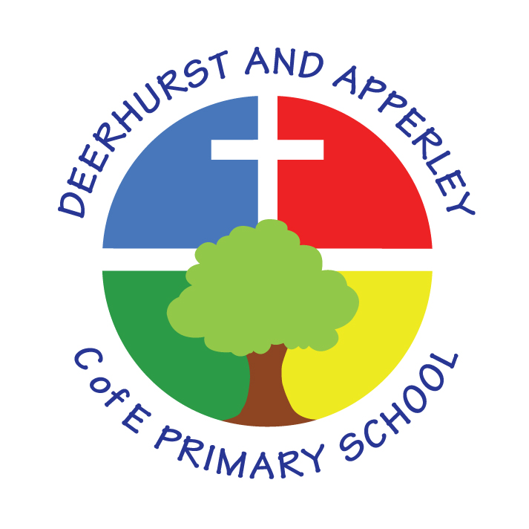

EYFS Induction
Reviewed March 2025

This document sets out the opportunities to parents and children to enter our EYFS setting and provides references to documents and expectations for all involved. The below list is a sample of initial contact for transition.

Parents who have requested a place at Deerhurst and Apperley receives a personal welcoming letter from the Headteacher and a notice of transition days and dates.
Foundation Stage Open Evening Induction

- Dates and times of visits into school

- Dates of start of term

- Home visits

- Uniform/spare clothes/PE KIT /wellies/named lunchboxes

- Book bags

- Parent pay / Money/Dinner money/ Trips

- Fruit/water bottle

- Parent helpers –

- Home/school agreement/internet safety

- Parent evenings

- Curriculum/Phonics/Continuous provision and assessment –

- Things to know before they start (dressing, shoes, socks, coats, toilets, teachers name)

- Breakfast/After School Care club /Clubs

This policy was approved by Governors 11th March 2025 and presented to staff March 2025

Approved by Governors

Signed: Mr Andrew Matthews Chair of Governors Date:11/03/25

Signed: 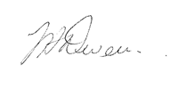 Head teacher Date:11/03/25

