Learning and living as children of God
(Ephesians5:1) (You are God’s children whom he loves. Try to be like God)

Deerhurst and Apperley C of E Primary School

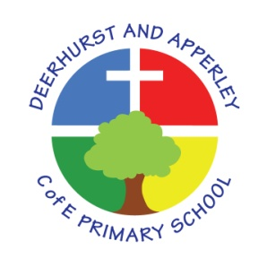
Acceptable Users Policy (young pupils)
June 2022
Review June 2025

This is how we stay safe when we use computers:
- I will ask a teacher or suitable adult if I want to use the computers / tablets
- I will only use activities that a teacher or suitable adult has told or allowed me to use
- I will take care of the computer and other equipment
- I will ask for help from a teacher or suitable adult if I am not sure what to do or if I think I have done something wrong
- I will tell a teacher or suitable adult if I see something that upsets me on the screen
- I know that if I break the rules I might not be allowed to use a computer / tablet
Name of child:
Signed (parent):

This policy was reviewed by staff and presented to the Full Governing Body for approval at the meeting of July 2022.

Head teacher: Jayne Neveu Signed: Date:

Chair of Governors:

