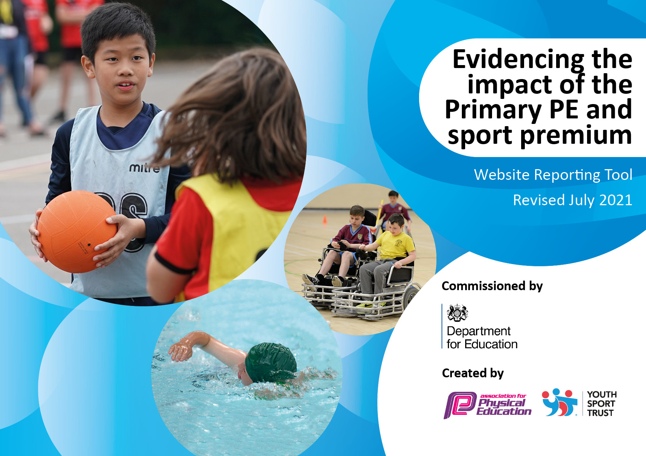
Sport Premium Intent 2022-23
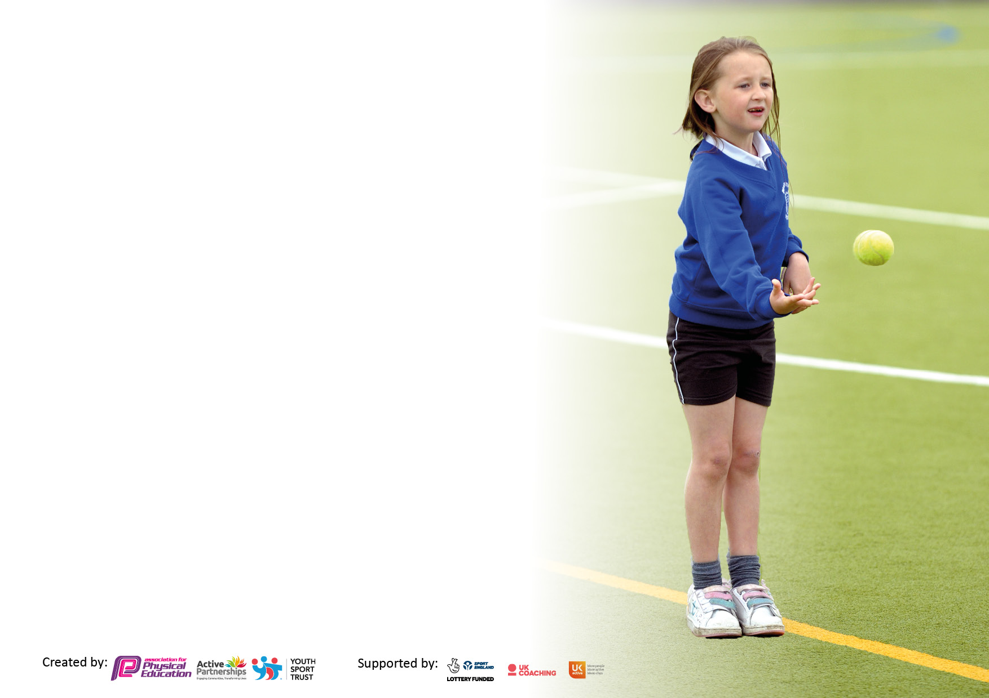

It is important that your grant is used effectively and based on school need. The Education Inspection Framework makes clear there will be a focus on ‘whether leaders and those responsible for governors all understand their respective roles and perform these in a way that enhances the effectiveness of the school’.

Under the Quality of Education Ofsted inspectors consider:
Intent - Curriculum design, coverage and appropriateness
Implementation - Curriculum delivery, Teaching (pedagogy) and Assessment
Impact - Attainment and progress

To assist schools with common transferable language this template has been developed to utilise the same three headings which should make your plans easily transferable between working documents.

Schools must use the funding to make additional and sustainable improvements to the quality of Physical Education, School Sport and Physical Activity (PESSPA) they offer. This means that you should use the Primary PE and sport premium to:

- Develop or add to the PESSPA activities that your school already offer
- Build capacity and capability within the school to ensure that improvements made now will benefit pupils joining the school in future years
- The Primary PE and sport premium should not be used to fund capital spend projects; the school’s budget should fund these.

Pleasevisitgov.ukfortherevisedDfEguidanceincludingthe5keyindicatorsacrosswhichschoolsshoulddemonstrate animprovement.Thisdocumentwillhelpyoutoreviewyourprovisionandtoreportyourspend.DfEencouragesschools to use this template as an effective way of meeting the reporting requirements of the Primary PE and sport premium.

We recommend you start by reflecting on the impact of current provision and reviewing the previous spend.

Details with regard to funding
Please complete the table below.

Total amount of funding for 2021/22. To be spent and reported on by 31st July 2022. | No Carry forward from 2022
Total amount of funding 2022-23 | £16,000 + £10 per child (£760) £16,760
Swimming Data
Please report on your Swimming Data below. Summer 2023

Meeting national curriculum requirements for swimming and water safety.

N.B. Complete this section to your best ability. For example you might have practised safe self-rescue techniques on dry land which you can then transfer to the pool when school swimming restarts.
Due to exceptional circumstances priority should be given to ensuring that pupils can perform safe self rescue even if they do not fully meet the first two requirements of the NC programme of study
What percentage of your current Year 6 cohort swim competently, confidently and proficiently over a distance of at least 25 metres? | %
What percentage of your current Year 6 cohort use a range of strokes effectively [for example, front crawl, backstroke and breaststroke]?  Please see note above | %
What percentage of your current Year 6 cohort perform safe self-rescue in different water-based situations? | %
Schools can choose to use the Primary PE and sport premium to provide additional provision for swimming but this must be for activity over and above the national curriculum requirements. Have you used it in this way? | Yes/No

Action Plan and Budget Tracking
Capture your intended annual spend against the 5 key indicators. Clarify the success criteria and evidence of impact that you intend to measure to evaluate for pupils today and for the future.

Academic Year: 2022-23 | Total fund allocated: | Date Updated:
Key indicator 1: The engagement of all pupils in regular physical activity – Chief Medical Officers guidelines recommend that primary school pupils undertake at least 30 minutes of physical activity a day in school |  |  |  | Percentage of total allocation:
 |  |  |  | 74%
Intent | Implementation |  | Impact | £12,450
Your school focus should be clear what you want the pupils to know and be able to do and about  what they need to learn and to  consolidate through practice: | Make sure your actions to achieve are linked to your intentions: | Funding allocated: | Evidence of impact: what do pupils now know and what can they now do? What has changed?: | Sustainability and suggested next steps:
Provide a broad and balanced extracurricular programme so that all children can access it in order to increase their physical activity levels and enjoyment for physical activity.  Target less active children and provide addition small group sessions where they can be taught about the importance of an active, healthy lifestyle, nurtured to include more activity in their day to day lives  All children to be physically active for at least 30 minutes a day everyday.  New cohort of EYFS Sept 2022, give children life skills to remain active outside of school times through learning to cycle early. They will also be able to develop their ‘language of feelings’.  The continued engagement of all pupils in regular physical activity – kick-starting healthy active lifestyles; Linking personal development with the latest Ofsted framework updated June 2021 section 27 Personal Development  The continued raised profile of PE and sport across the school for whole school improvement;  Continued confidence, knowledge and skills of all staff in teaching PE and sport;  Continued experience of a range of sports and activities offered to all pupils;  Continued increased participation in competitive sport.  Ensure focused health and well-being sessions will be available for children, this will include mental health.  . Equipment provided will enable break times to be active  To ensure children have access to swimming  Health and well-being opportunities to raise profile of mental health and how that links to physical activity  To hold whole school activity – ‘Healthy Week’  Promote health and well being linked to the above by engaging with more outdoor learning and additional small targeted groups | Source additional coaches to help deliver after school sports clubs so that a broader range of clubs are on offer  All children will have access to clubs but school will also target vulnerable children. Clubs will run during lunchtime and after school  Time set aside during the school day for these sessions to ensure attendance with Progressive Sports coach  Mile A Day focus  All breaktimes to have dedicated play equipment  Provide Balanceability cycling to reception children- term 1  Children will be able to engage in a ‘new’ sport in school and this will be in response to the success experienced of the children and listening to their interests  CPD opportunity for staff. New coach from Progressive Sport will introduce new sport to school  Deerhurst and Apperley Primary School will achieve this overview by:  Continuing to employ an experienced sports specialist to support the teaching of PE & Sport and to provide professional development to all staff & coordinate and expand extra-curricular PE in school.  Book dance and fitness classes through the autumn term (initially)  Progressive Sport Street Dance KS1  Continuing to improve resources in school for delivering high quality PE.  Developing healthy lifestyles  through increased opportunities.  Improving physical levels during lunchtimes  Continue with The Daily Mile for all children  Increasing school sports opportunities within school time and after school clubs  Increase awareness of nutrition and the impact on healthy lifestyles ( link to mental health drive)  Engage parents on the importance of healthy snacks  Increase awareness on mental well-being and the impact on health by having a dedicated session for outdoor learning and developing deeper understanding of online safety  Y6 children will be able to swim 25 metres by the end of Y6 if needed money will be directed outside of curriculum requirements (Heidi’s heroes for those who can’t swim)  Playtime buddies will raise profile of games at break times  Sports specialist will engage vulnerable groups during breaktimes  Invite in a cook for nutritional cooking  A variety of coaches to expose the children to different activities  First Aid experience for all children  Qualified school Forest Leader will lead Forest School on a rota and provide CPD for staff. | £700 - staffing  -coaches  £650 10 weeks  £9200  £500  £500  £900 | Intention of impact  Children more knowledgeable of different activities. Greater confidence to take part in physical activity and sport, more likely to join a club outside of school Fitter, healthy children  Children able to swim 25m, use a range of strokes and perform safe self-rescue skills  All children will have a basic understanding of First aid and will be able to respond to such  Cooking skills and nutritional understanding will improve (this also links to the well being survey completed by Y4/Y6 July 2022, where their desire was to have more cooking skills  Children will engage in Forest School and their mental Health and Well being will improve.  Targeted children will have longer focused periods of concentration in class as a result of targeted outdoor learning in the Forest School. | Engage children in after school clubs on a more regular basis  All children to be physically active for at least 30 minutes a day everyday.  New cohort of EYFS Sept 2022, give children life skills to remain active outside of school times through learning to cycle early. They will also be able to develop their ‘language of feelings’.  The continued engagement of all pupils in regular physical activity – kick-starting healthy active lifestyles; Linking personal development with the latest Ofsted framework updated June 2021 section 27 Personal Development  The continued raised profile of PE and sport across the school for whole school improvement;  Continued confidence, knowledge and skills of all staff in teaching PE and sport;  Continued experience of a range of sports and activities offered to all pupils;  Continued increased participation in competitive sport. Build on the 4 Gold School Sports Award and obtain Platinum  Ensure focused health and well-being sessions will be available for children, this will include mental health.  . Equipment provided will enable break times to be active  To ensure children have access to swimming  Health and well-being opportunities to raise profile of mental health and how that links to physical activity  To hold whole school activity – ‘Healthy Week’
Key indicator 2: The profile of PESSPA being raised across the school as a tool for whole school improvement |  |  |  | Percentage of total allocation:
 |  |  |  | 0.6%
Intent | Implementation |  | Impact | £100
Your school focus should be clear what you want the pupils to know and be able to do and about  what they need to learn and to  consolidate through practice: | Make sure your actions to achieve are linked to your intentions: | Funding allocated: | Evidence of impact: what do pupils now know and what can they now do? What has changed?: | Sustainability and suggested next steps:
Weekly celebrations of achievements, photographs, write ups  Sports Blog/photographs and updates | Staff time | £100 | Raise profile for all

Key indicator 3: Increased confidence, knowledge and skills of all staff in teaching PE and sport |  |  |  | Percentage of total allocation:
 |  |  |  | 19%
Intent | Implementation |  | Impact | £3200
Your school focus should be clear | Make sure your actions to | Funding | Evidence of impact: what do | Sustainability and suggested
what you want the pupils to know | achieve are linked to your | allocated: | pupils now know and what | next steps:
and be able to do and about | intentions: |  | can they now do? What has
what they need to learn and to |  |  | changed?:
consolidate through practice:
Use of Move More membership to provide CPD in areas identified by staff  Use employed sports specialist to deliver CPD  We will continue to secure the services of a number professional coaches to both broaden the children’s sporting experiences and allow our teachers to develop their own skills.  All members of teaching staff will have access to 6 weeks of professional sports coaches to support their development in specific sporting areas  Forest School will be regular and engaging | Membership fee covers CPD  Staff will become more confident  In delivering PE  All pupils will learn a new and exciting package of physical activities  All staff will develop skills and knowledge  Learning will be applied through outdoor activities that are engaging for all | £27000  £9200(counted above)  £500  £900 (counted above) | All pupils will have the opportunity of competitive sport  Staff will be continually upskilled  Staff will become upskilled in areas they have identified as room for improvement or developing | All pupils will be exposed to competitive sports outside of own school – continue with experts to enable upskilling  Long term delivery of lessons will be from an informed and skilled delivery  All staff will be part of 2022-23 Forest School learning
Key indicator 4: Broader experience of a range of sports and activities offered to all pupils |  |  |  | Percentage of total allocation:
 |  |  |  | 6%
Intent | Implementation |  | Impact | £1000
Your school focus should be clear | Make sure your actions to | Funding | Evidence of impact: what do | Sustainability and suggested
what you want the pupils to know | achieve are linked to your | allocated: | pupils now know and what | next steps:
and be able to do and about | intentions: |  | can they now do? What has
what they need to learn and to |  |  | changed?:
consolidate through practice:
Plan for a whole school dance day to celebrate diversity and develop children’s dance skills | Children will learn dance skills that transfer to knowledge of dance around the world | £1000
Develop resources for EYFS to build on core skills of the EYFS profile  Hold a whole school ordnance/orienteering day – adventurous opportunity | Employ Progressive sport for a Mission Survive Thrive opportunity for whole school – link to cross curricular maths/geog | PTFA  PTFA

Key indicator 5: Increased participation in competitive sport |  |  |  | Percentage of total allocation:
 |  |  |  | %
Intent | Implementation |  | Impact
Your school focus should be clear | Make sure your actions to | Funding | Evidence of impact: what do | Sustainability and suggested
what you want the pupils to know | achieve are linked to your | allocated: | pupils now know and what | next steps:
and be able to do and about | intentions: |  | can they now do? What has
what they need to learn and to |  |  | changed?:
consolidate through practice:
Move More membership and involvement in area-wide activities at each Key Stage  School-based competitions largely run by Sports Crew | High percentage of pupils competing against other schools  Every pupil involved in school based competitions, at various times throughout the year | £2700 (as above | All pupils will have access to competitive sport outside of school environment
Provide Transport to Competitive Sporting Events |  | Voluntary contribultions | All children will have access to competitions

Signed off by
Head Teacher: | Jayne Neveu
Date: | September 2022
Subject Leader: | JN/NR (temp)
Date: | Sept 2022
Governor: | Mrs Kathryn Witney
Date: | Sept 2022

